Section 15 & 16: Serverless

AWS Solution Architect Associate

# Section 15: Serverless overviews from a Solution Architect perspective

## 173. Serverless Introduction

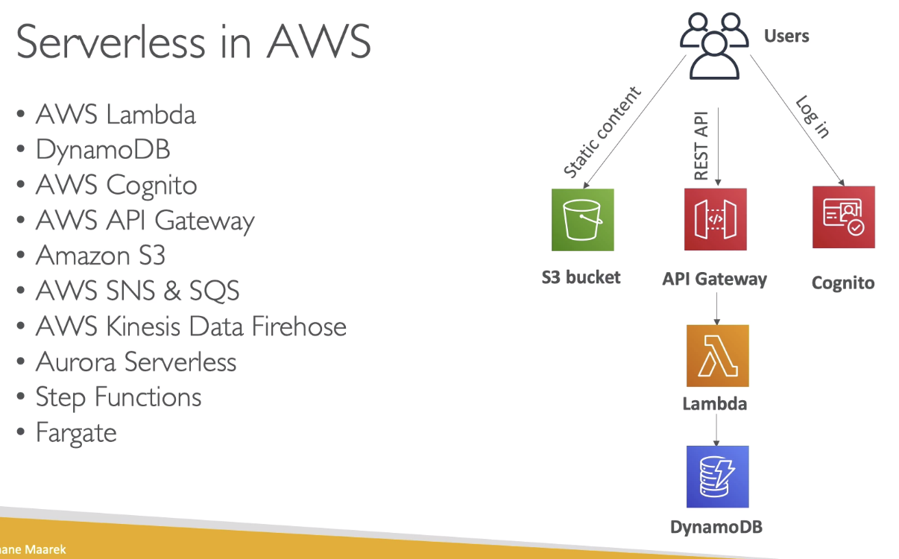

## 174. Lambda Overview

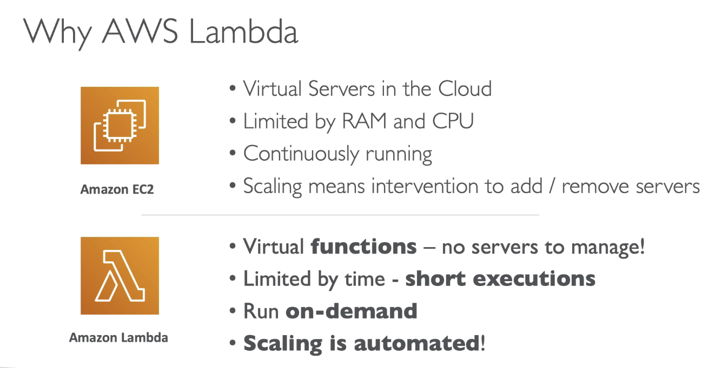

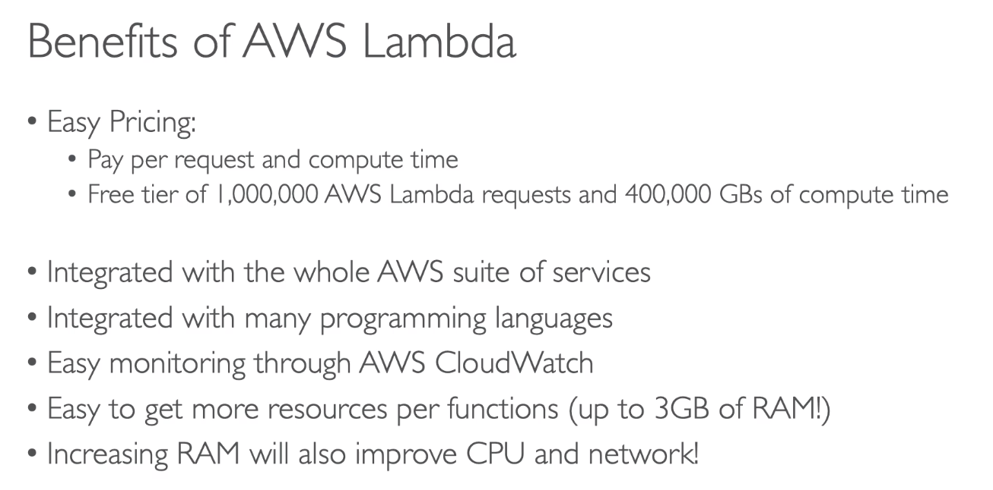

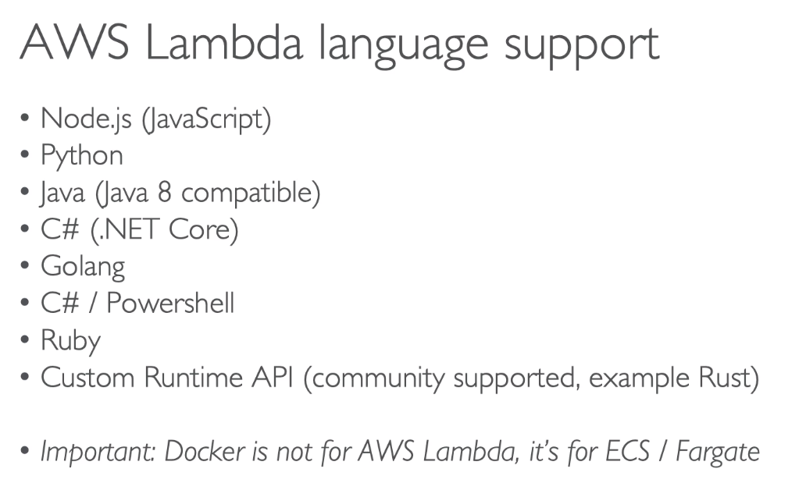

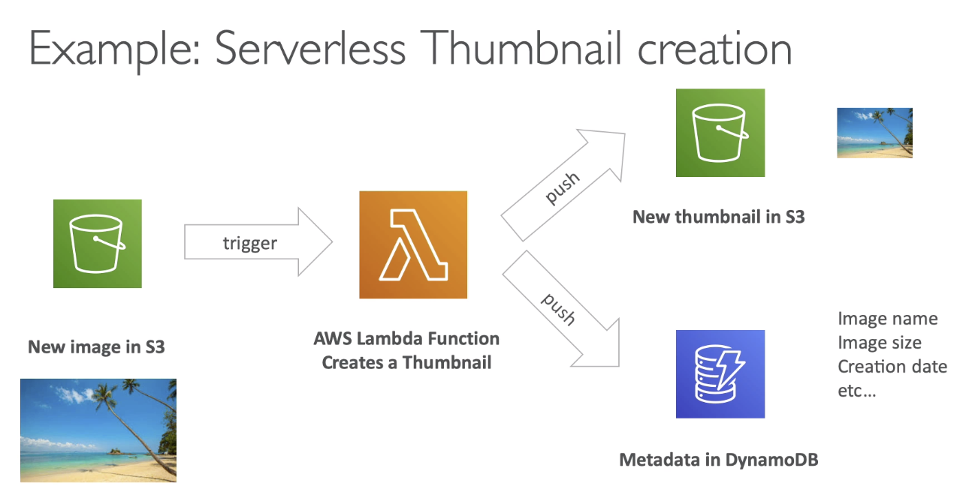

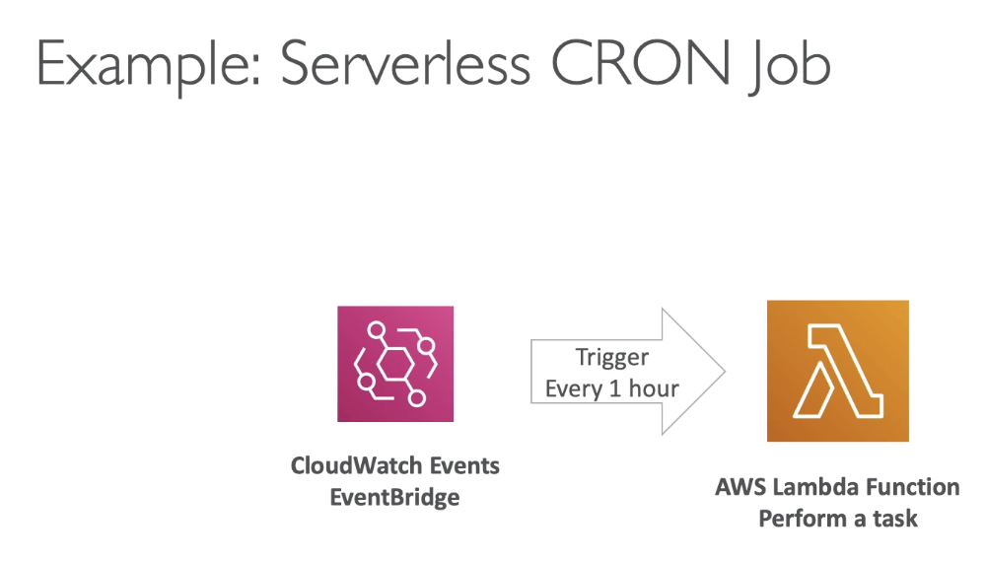

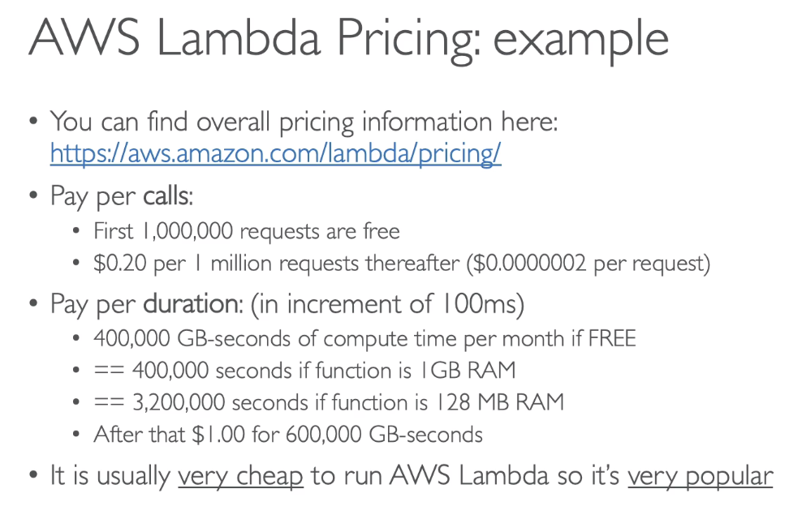

## 175. Lambda Hands On

## 176. Lambda Limits

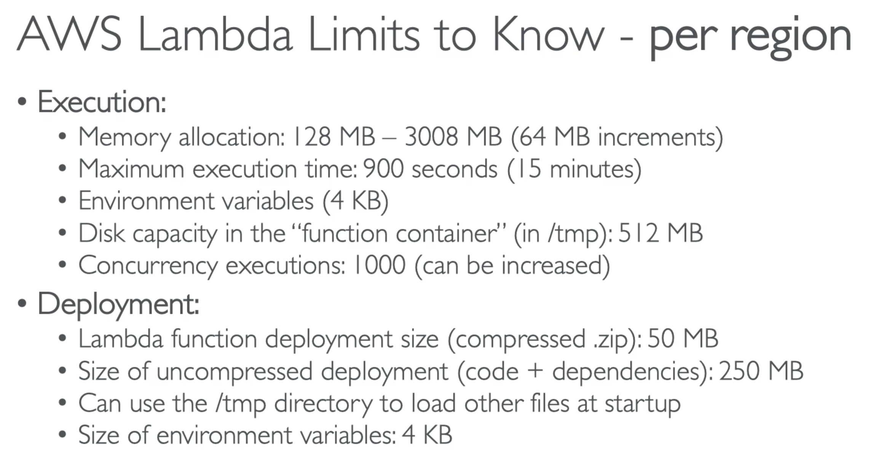

**If exam questions gives scenario such as, we need 6GB RAM, 30 min execution time, or we need a big file of 3GB 🡪 then know that Lambda is not the right way to run this workload.

## 177. Lambda@Edge

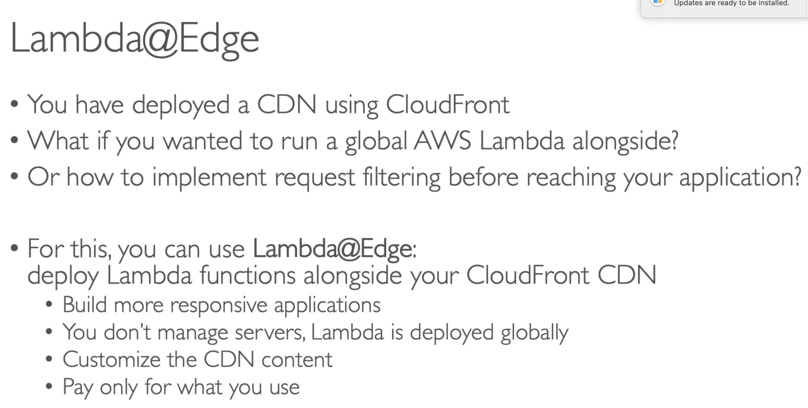

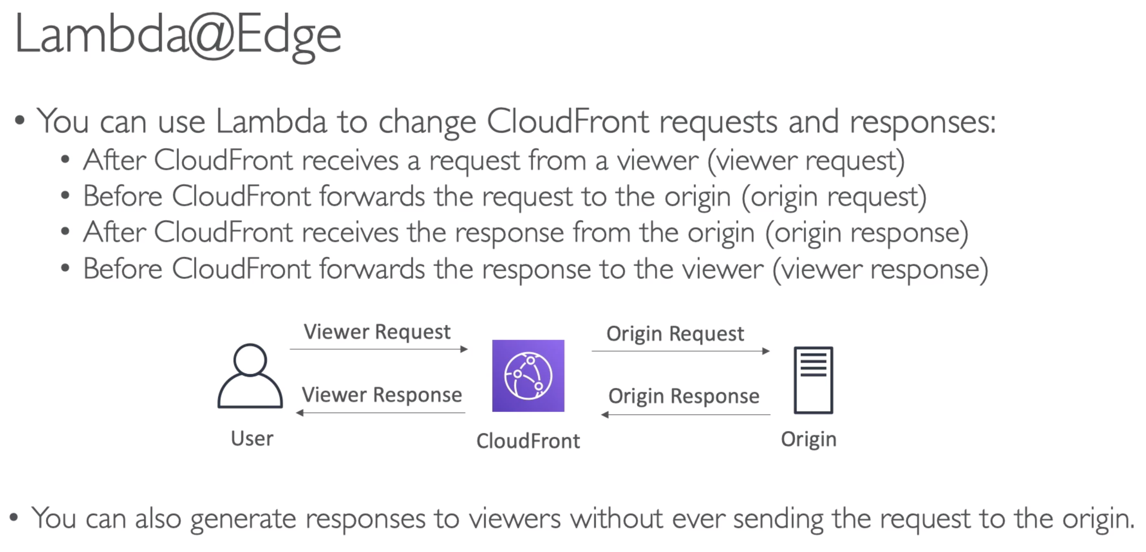

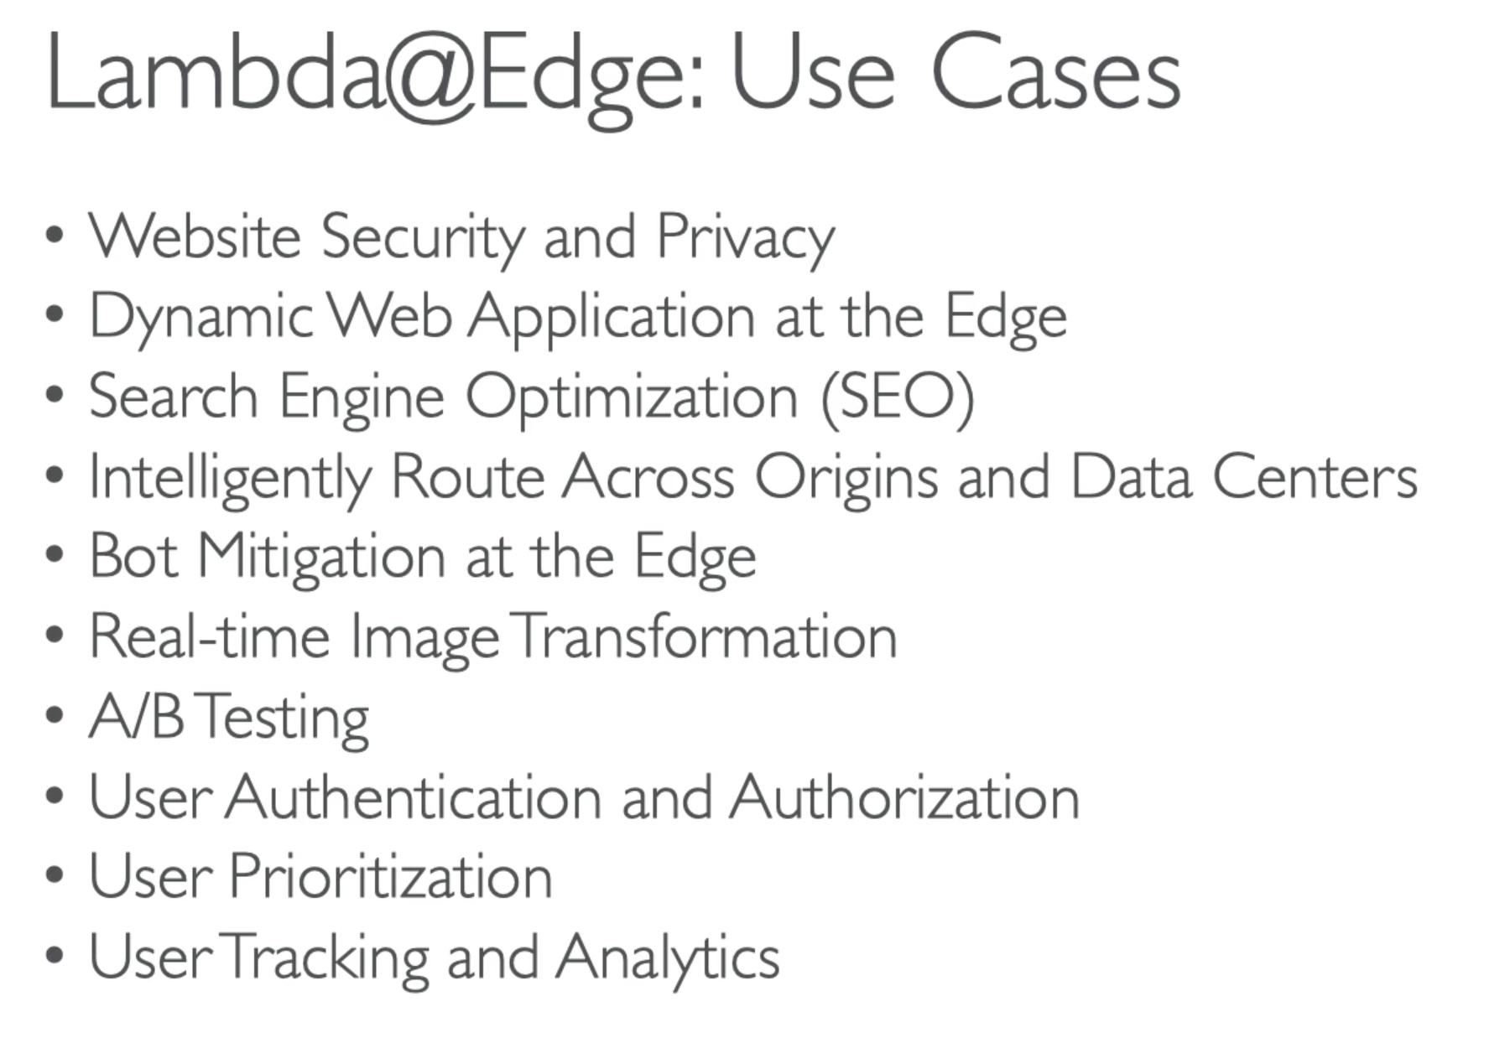

**Labmda@Edge is used whenever you need to integrate a lambda function with your CloudFront distribution to modify these 4 kind of requests…

* Viewer Request
* Viewer Response
* Origin Request
* Origin Response

## 178. DynamoDB Overview

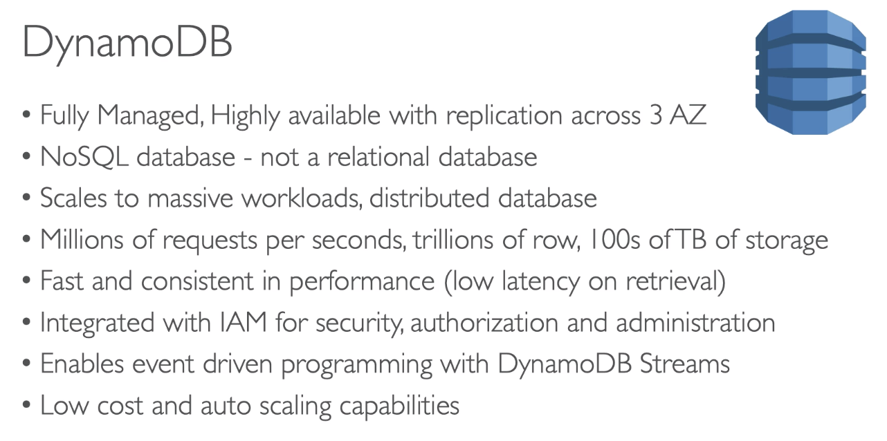

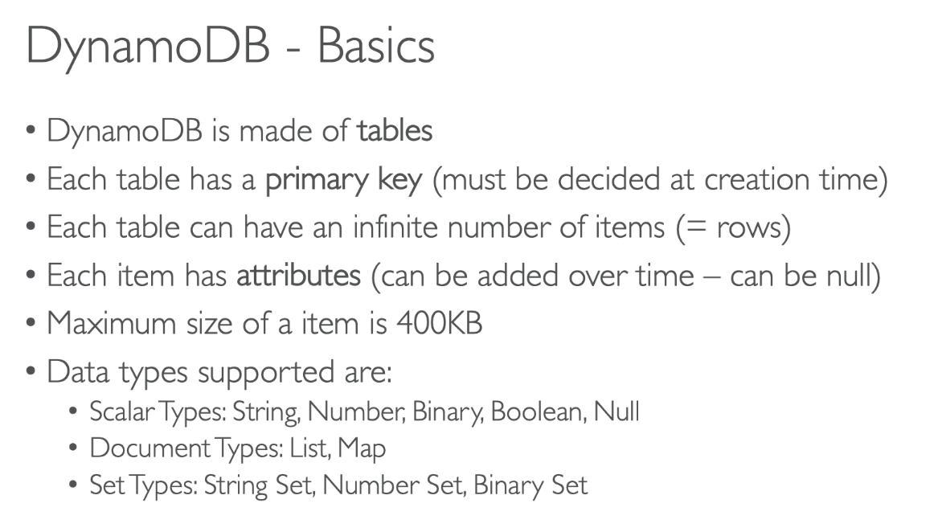

*You do not need to create a database, just start creating tables …

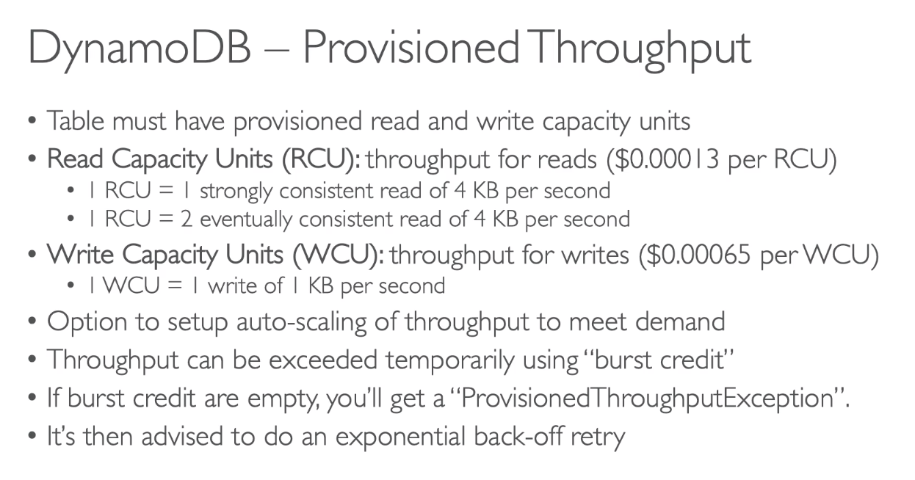

## 179. DynamoDB Hands-On

## 180. DynamoDB Advanced Feature

### DAX

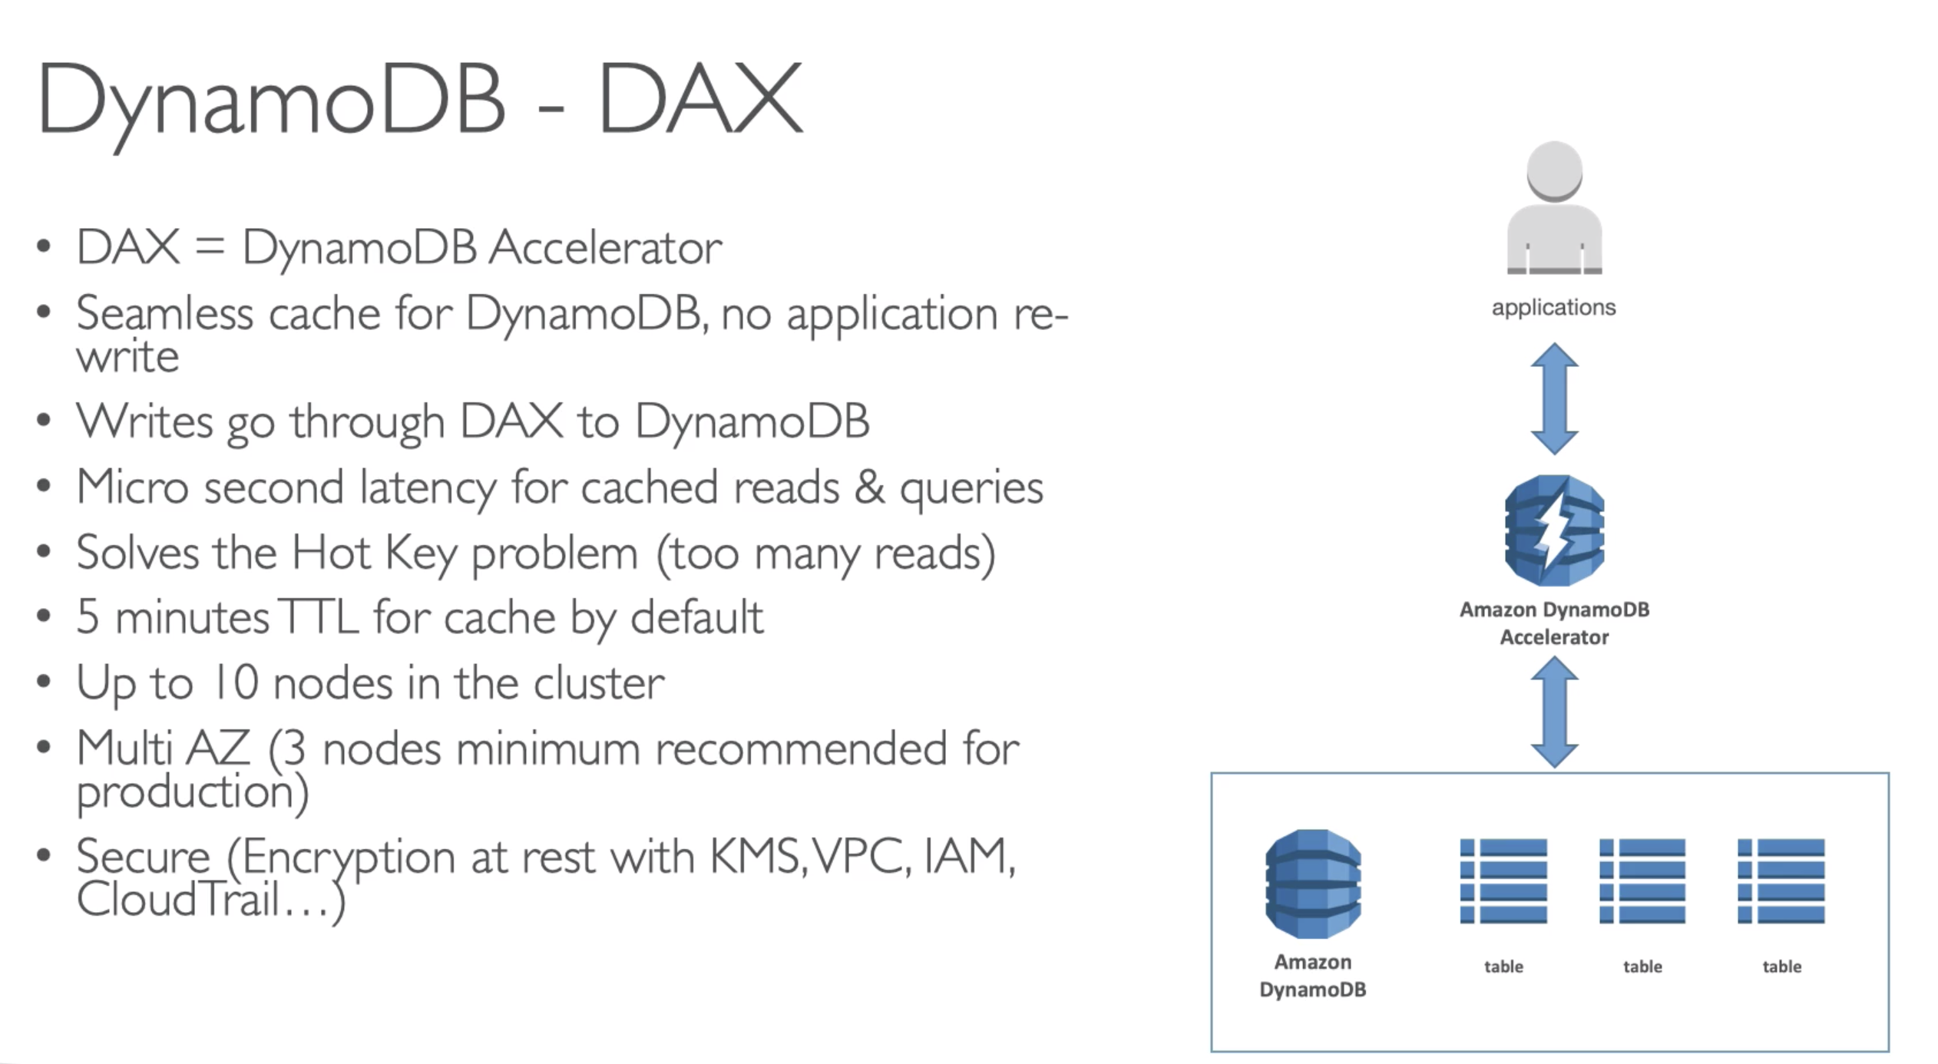

### Streams

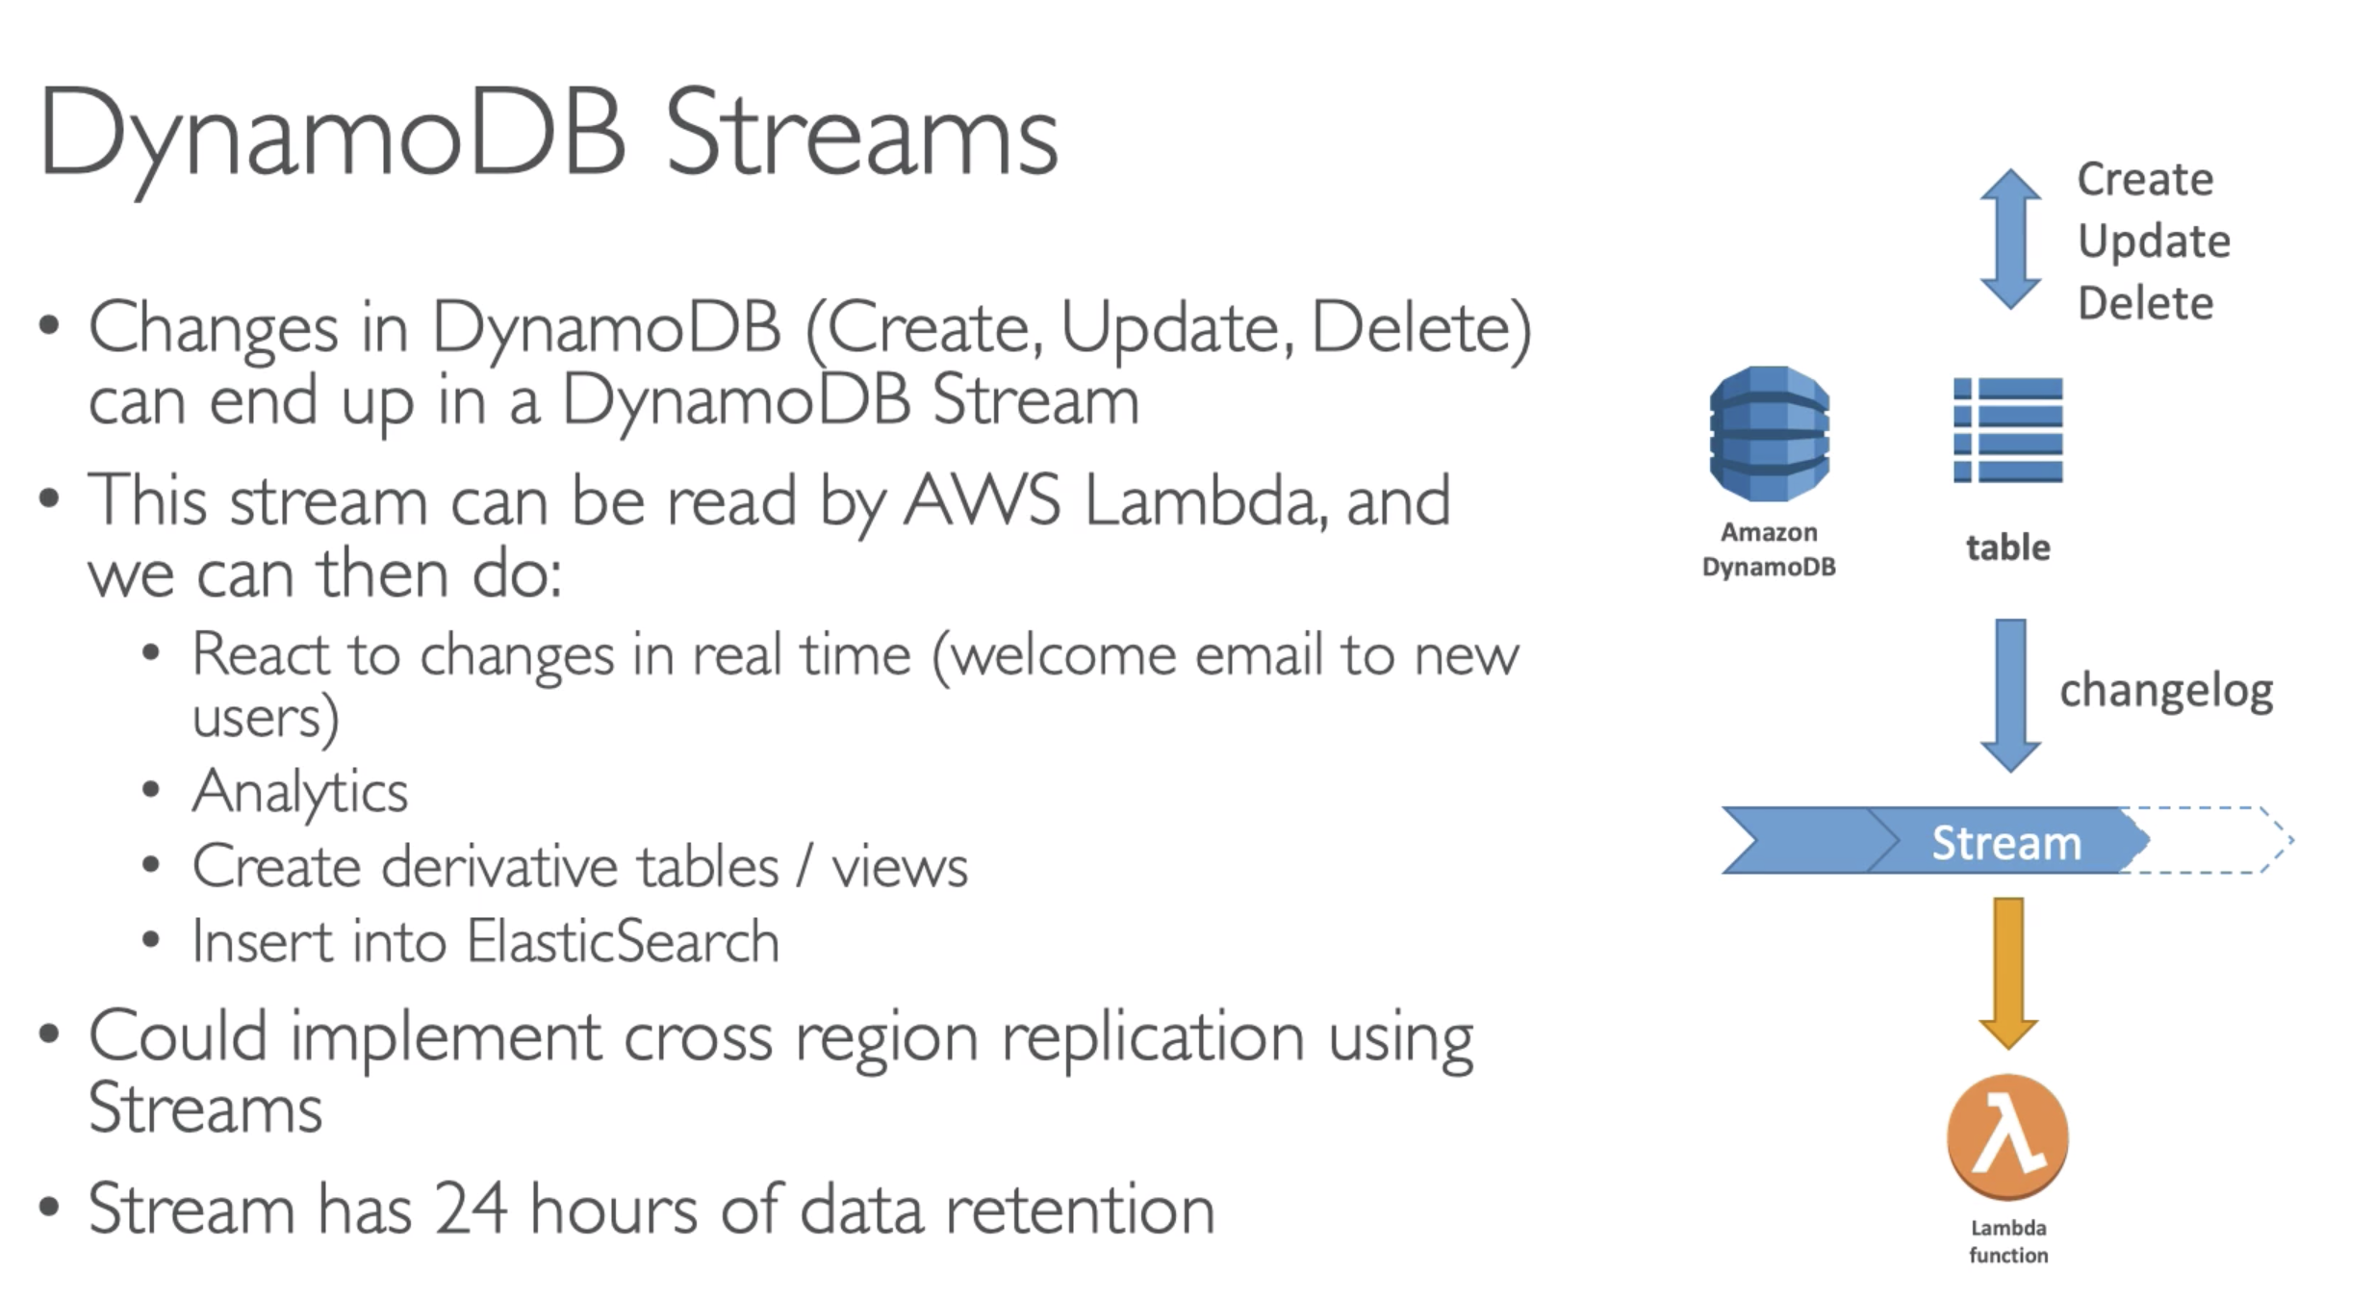

*Stream is mainly used to integrate Lambda function with DynamoDB

### Security

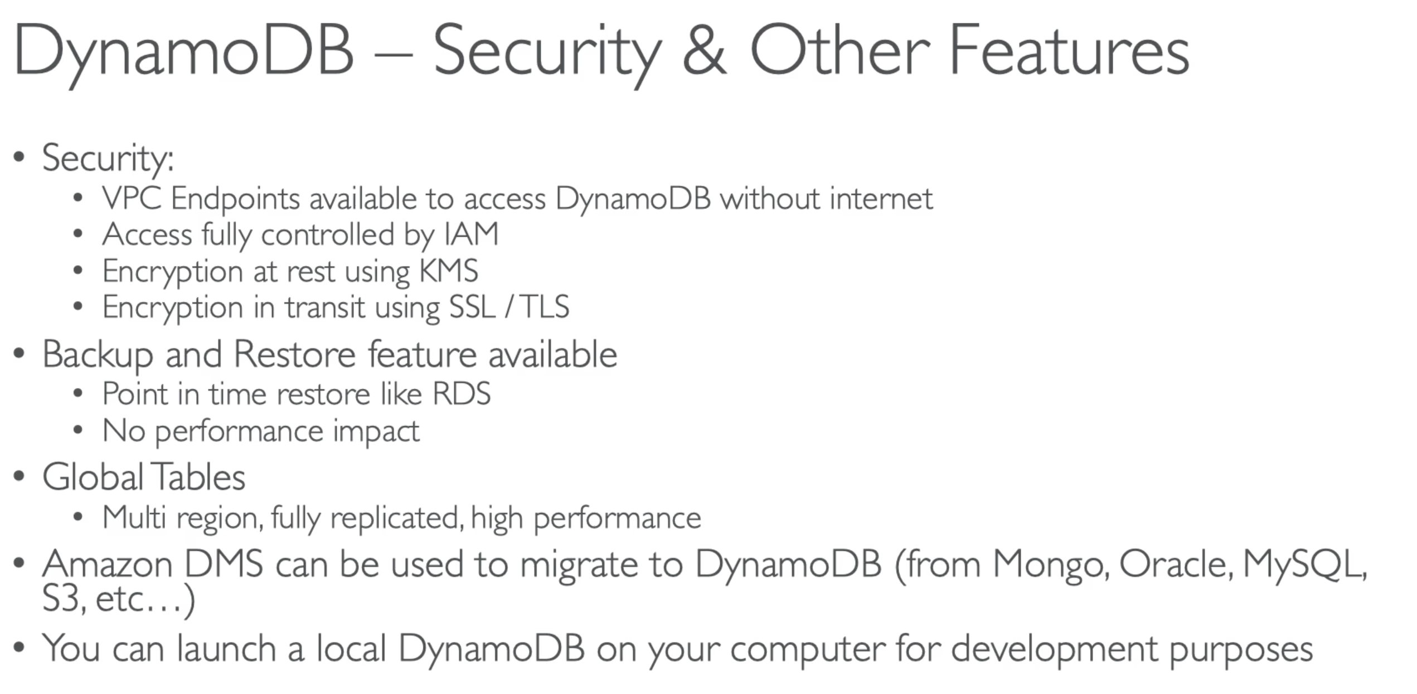

## 181. API Gateway Overview

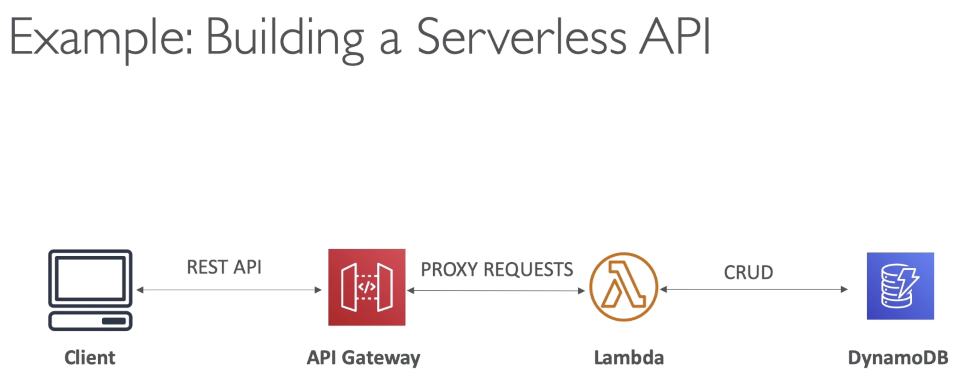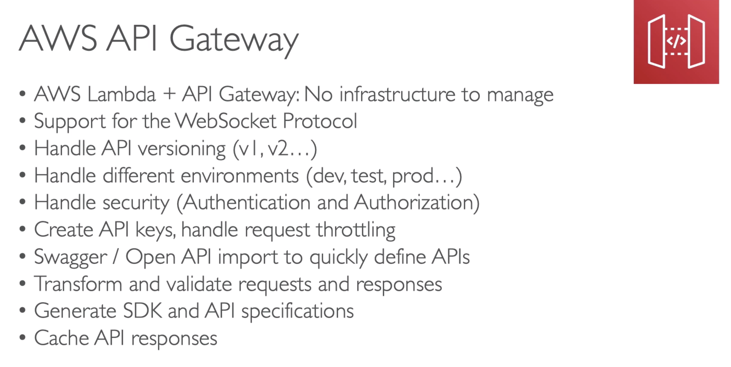

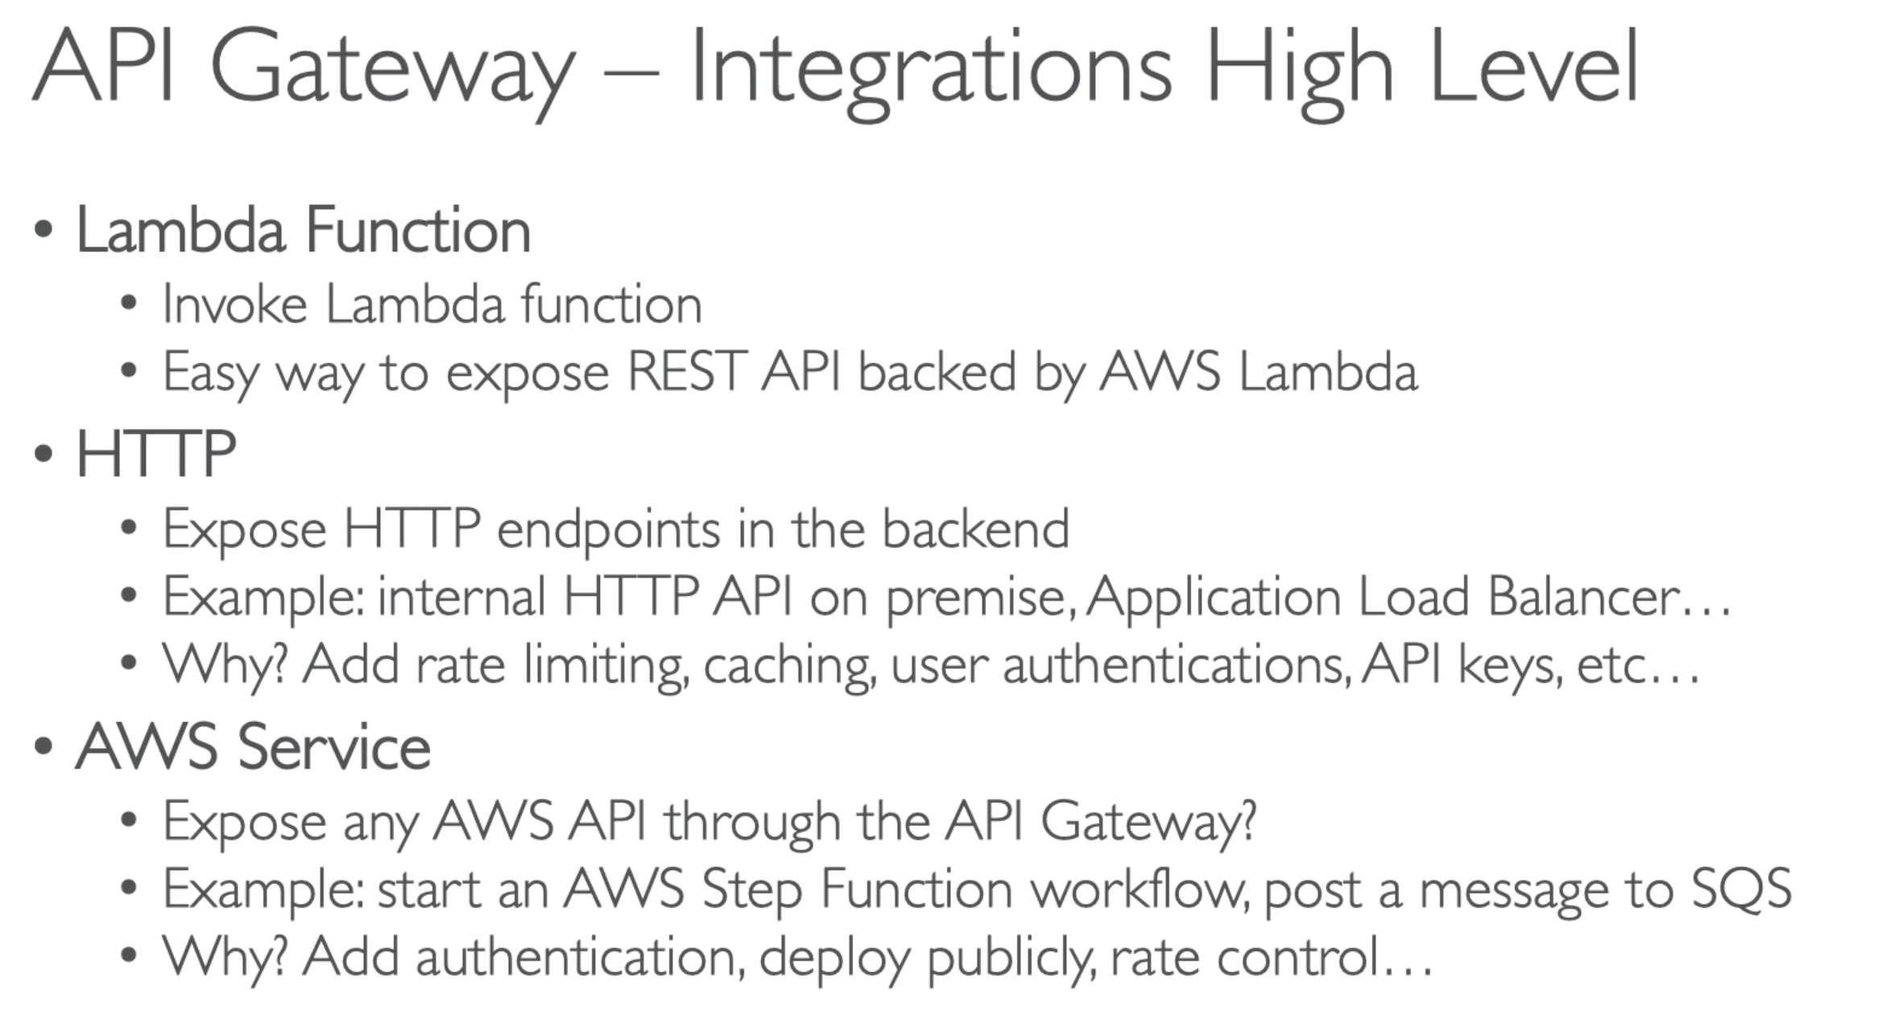

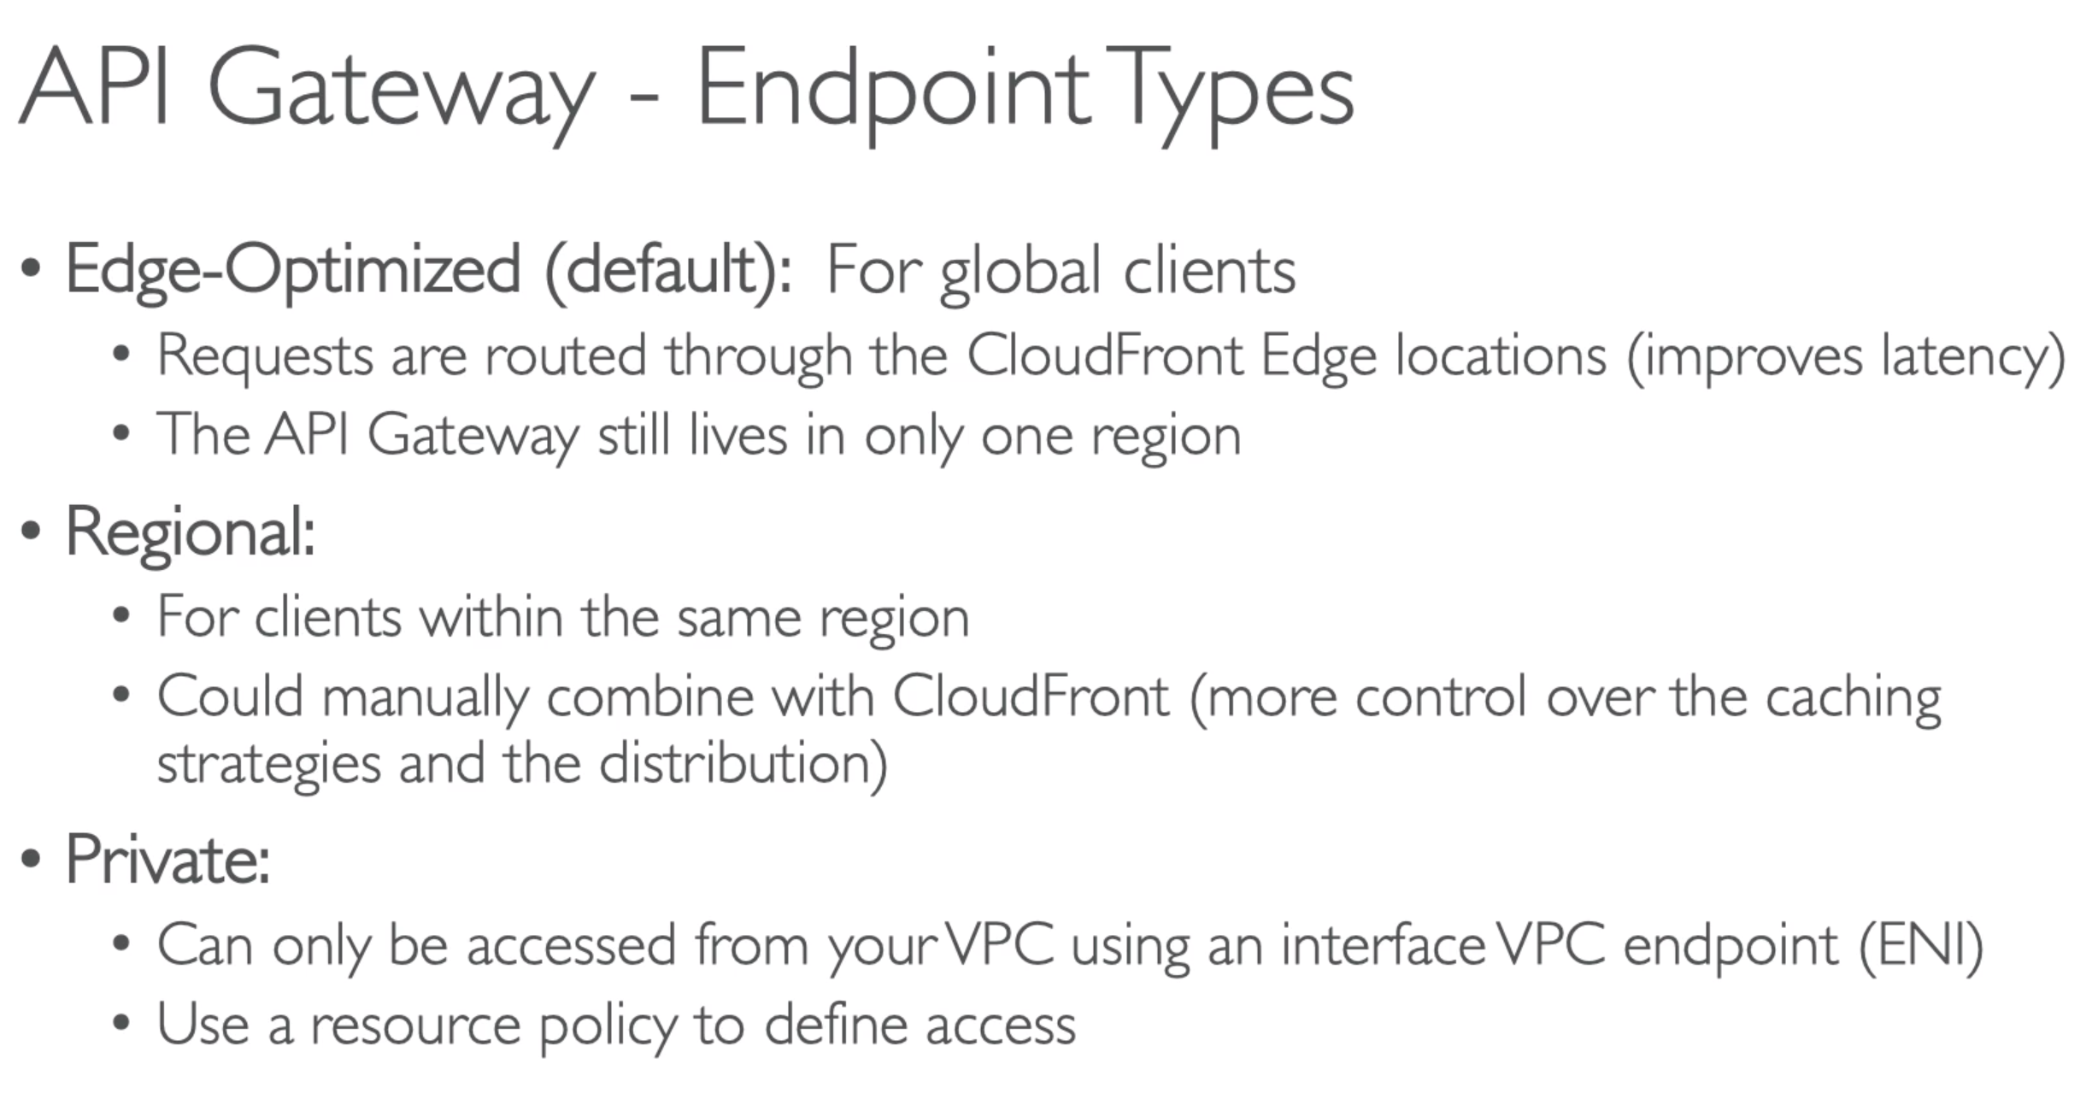

## 182. API Gateway Basics Hands-On

## 183. API Gateway Security

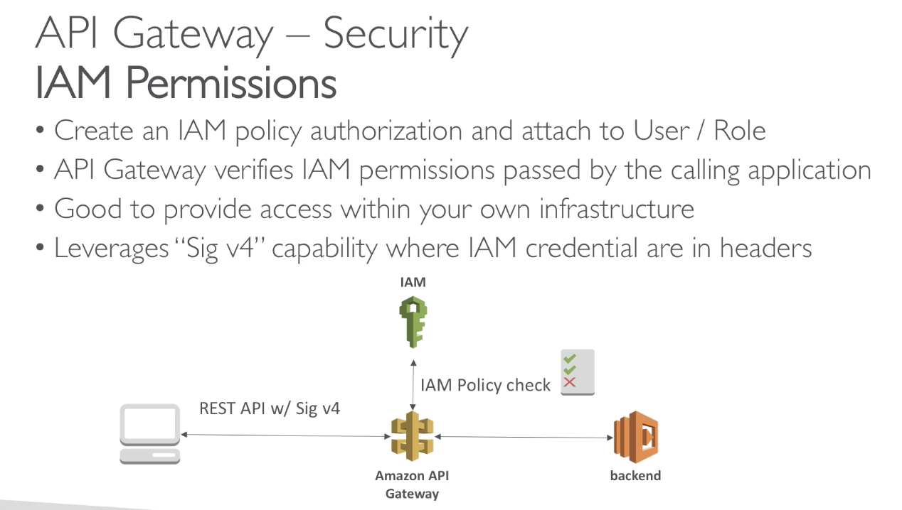

* Anytime you see Sig v4 🡪 think of IAM Permission for API Gateway
* If you give access to users outside of your AWS, then you can’t use IAM Permissions, Obviously.

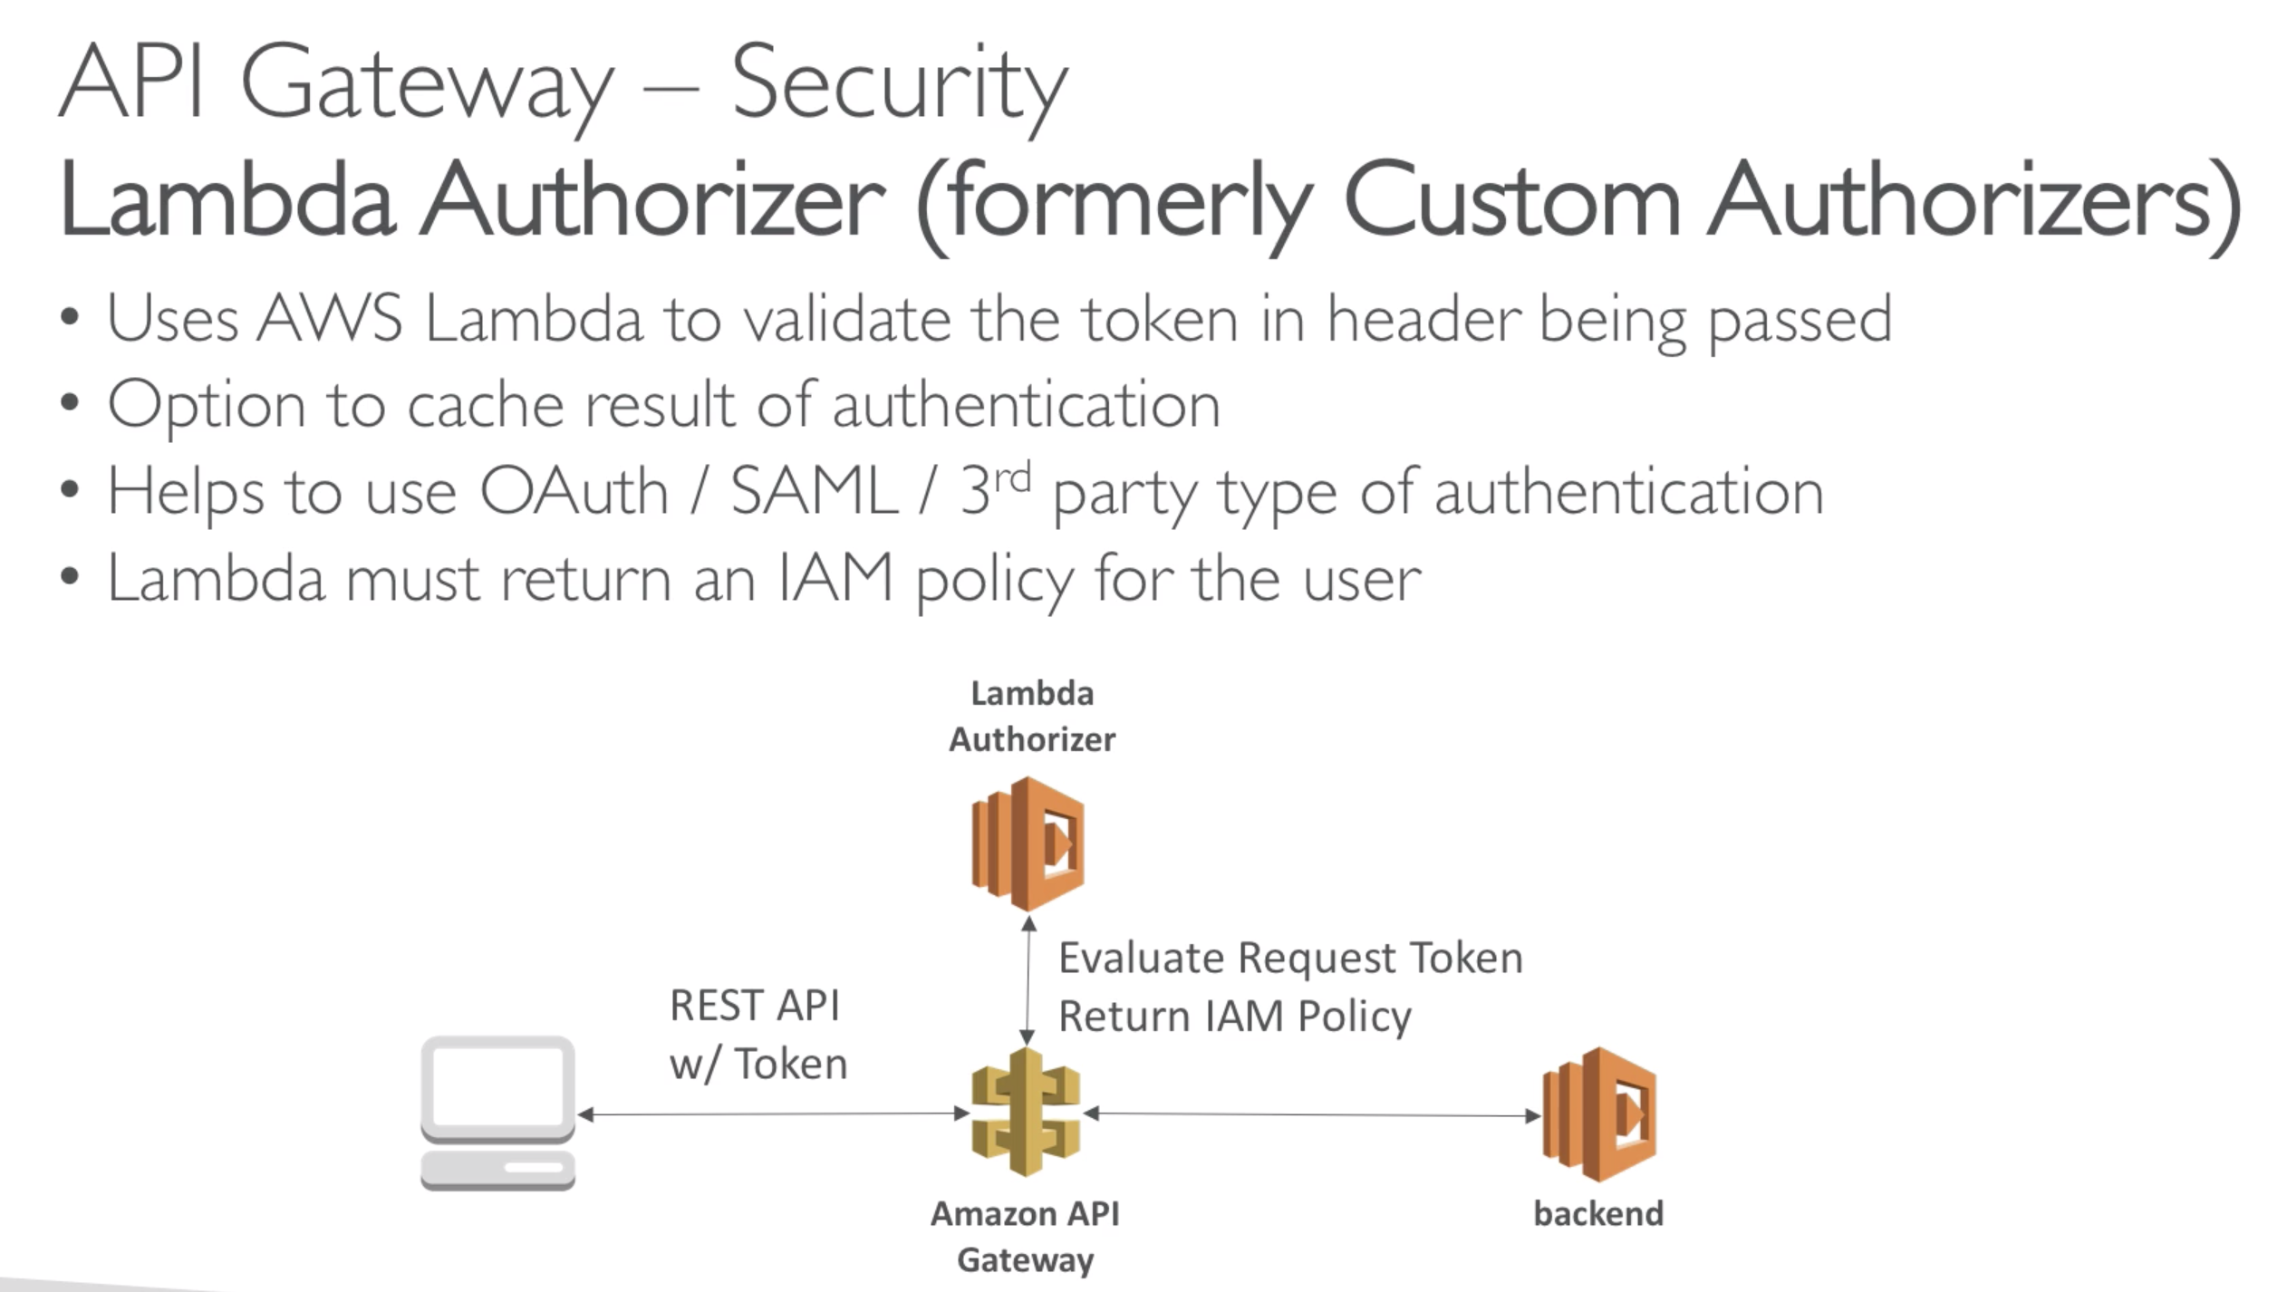

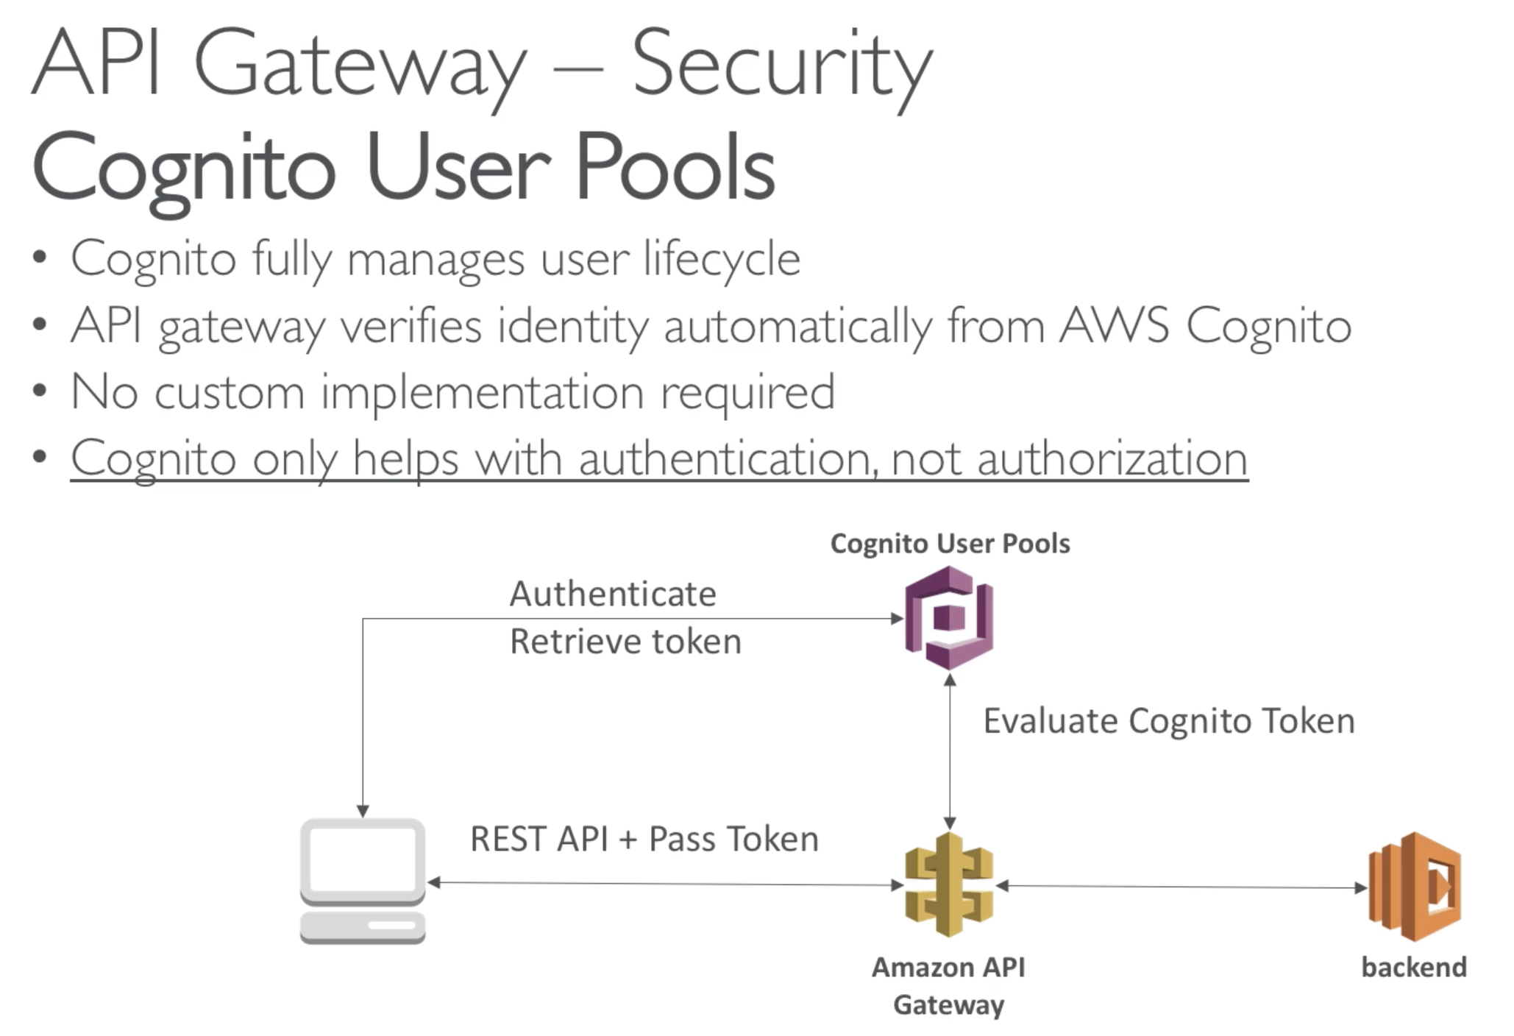

* Backend must authorise that you can make the call

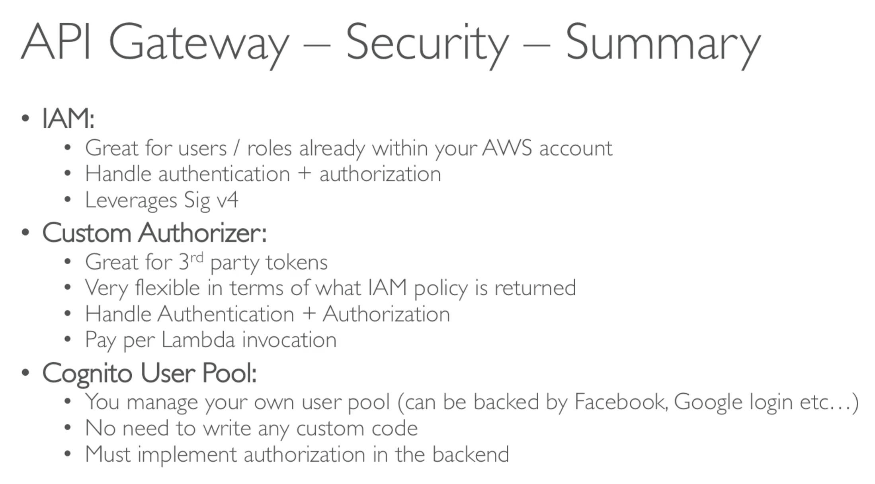

## 184. AWS Cognito Overview

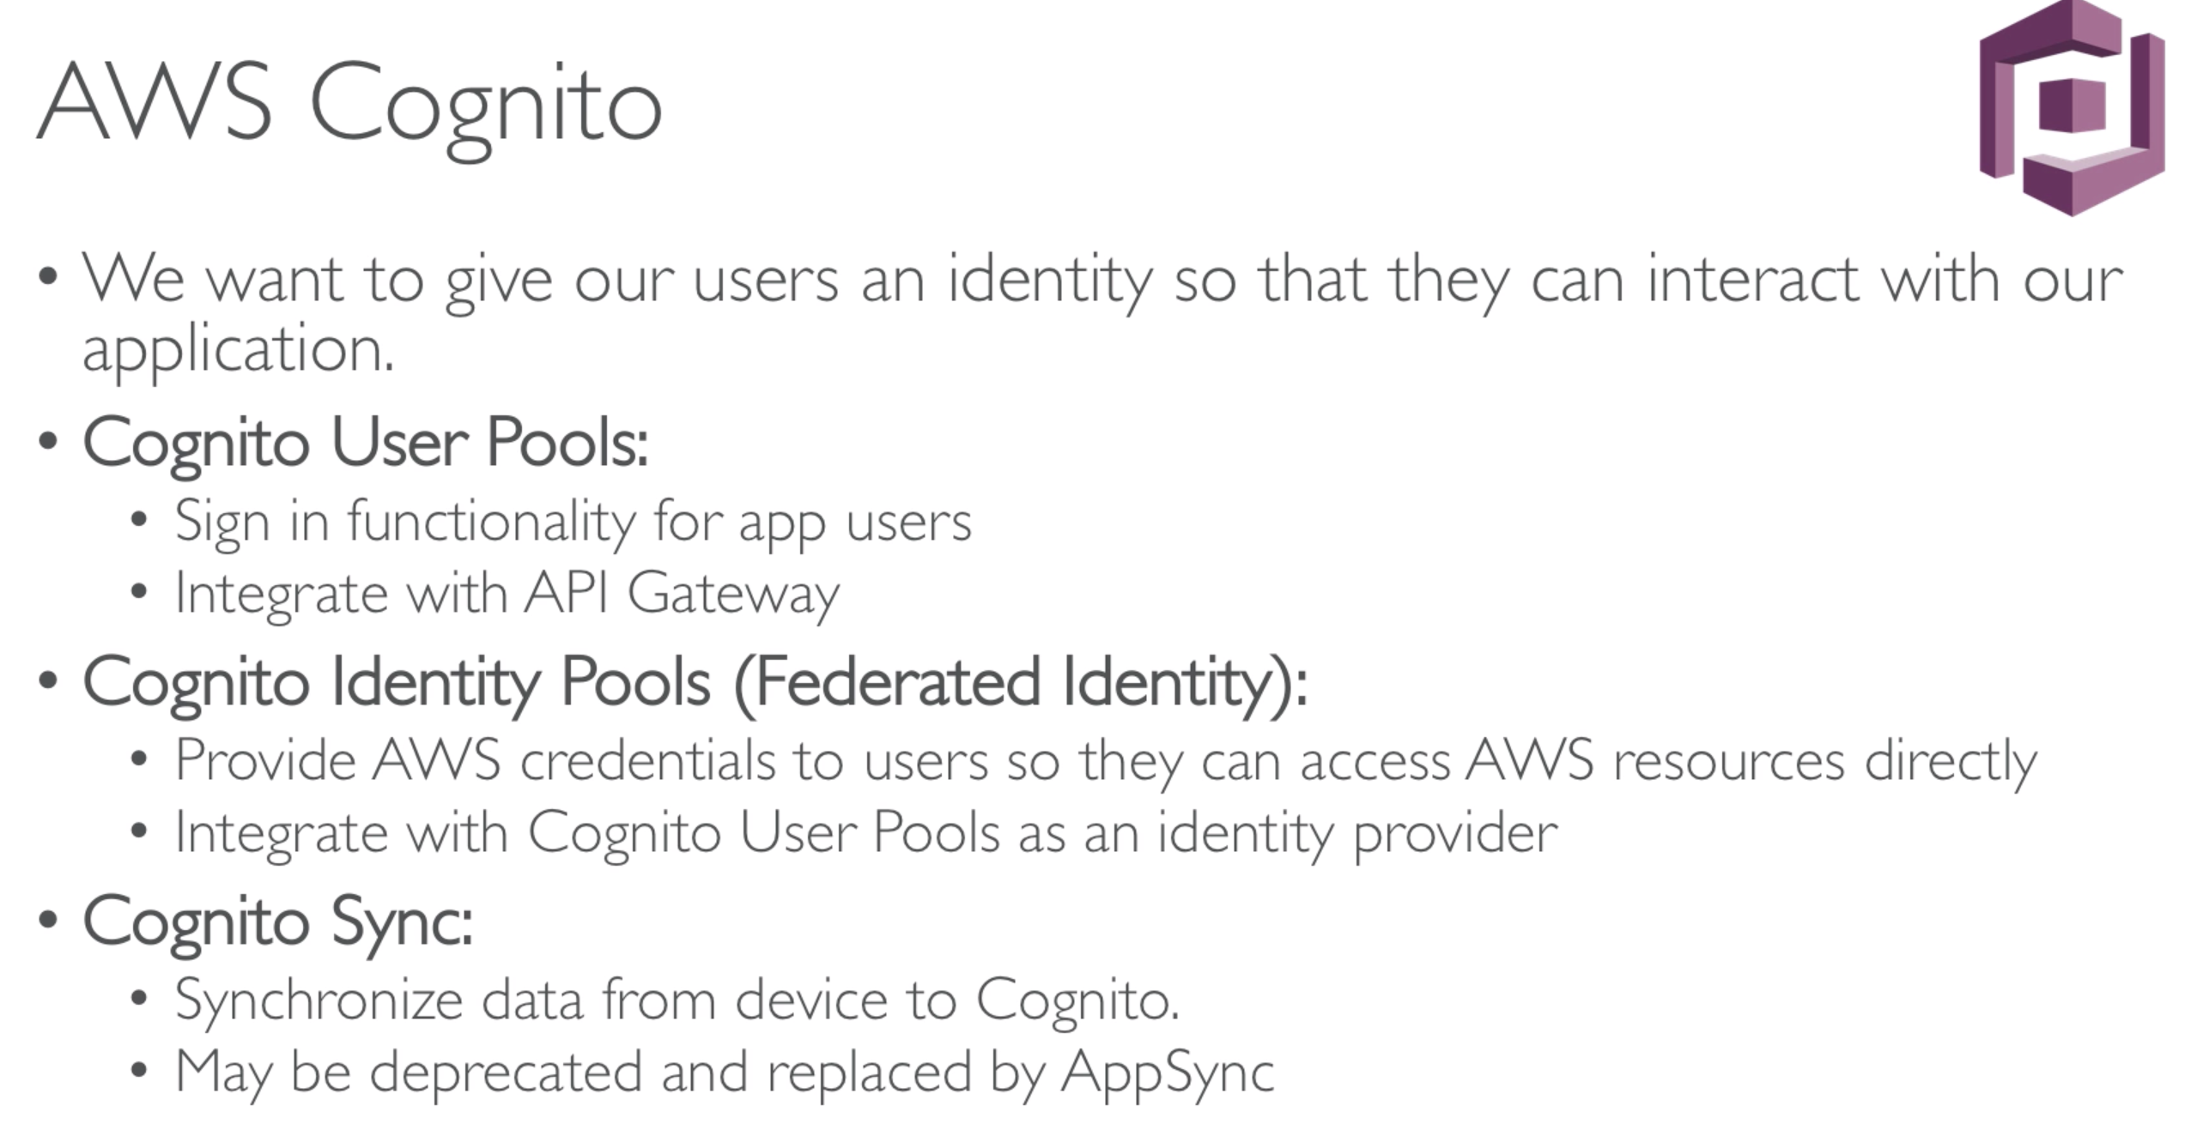

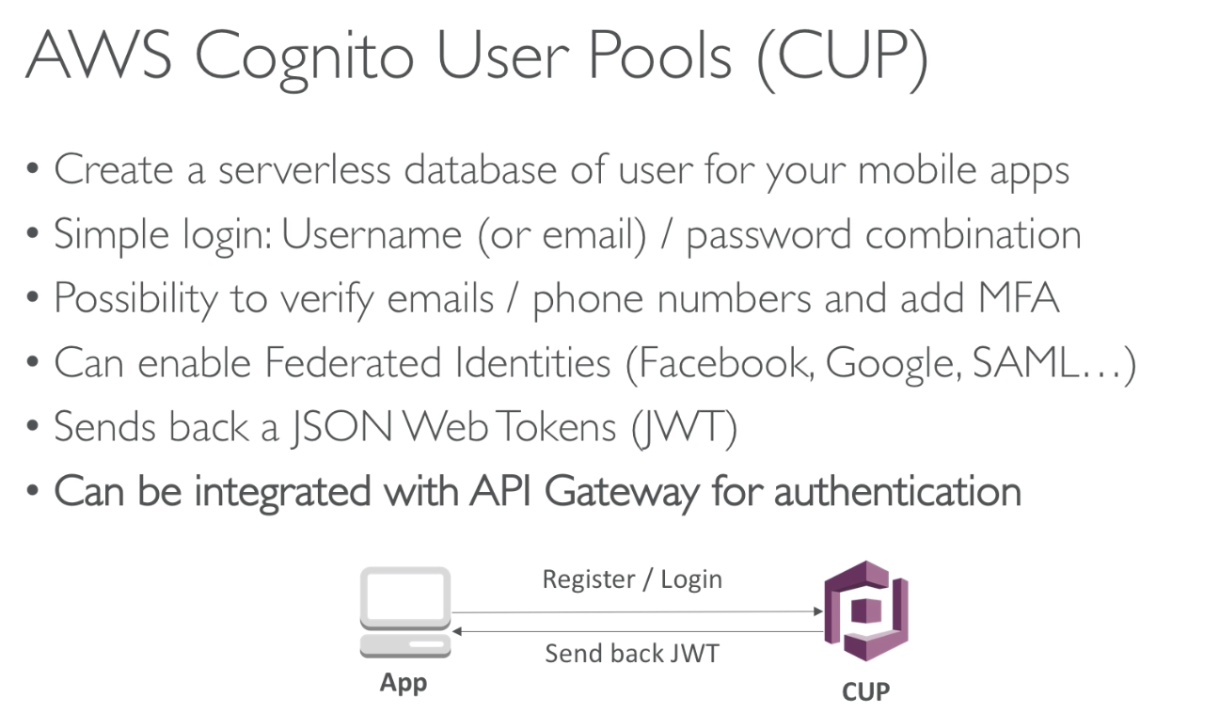

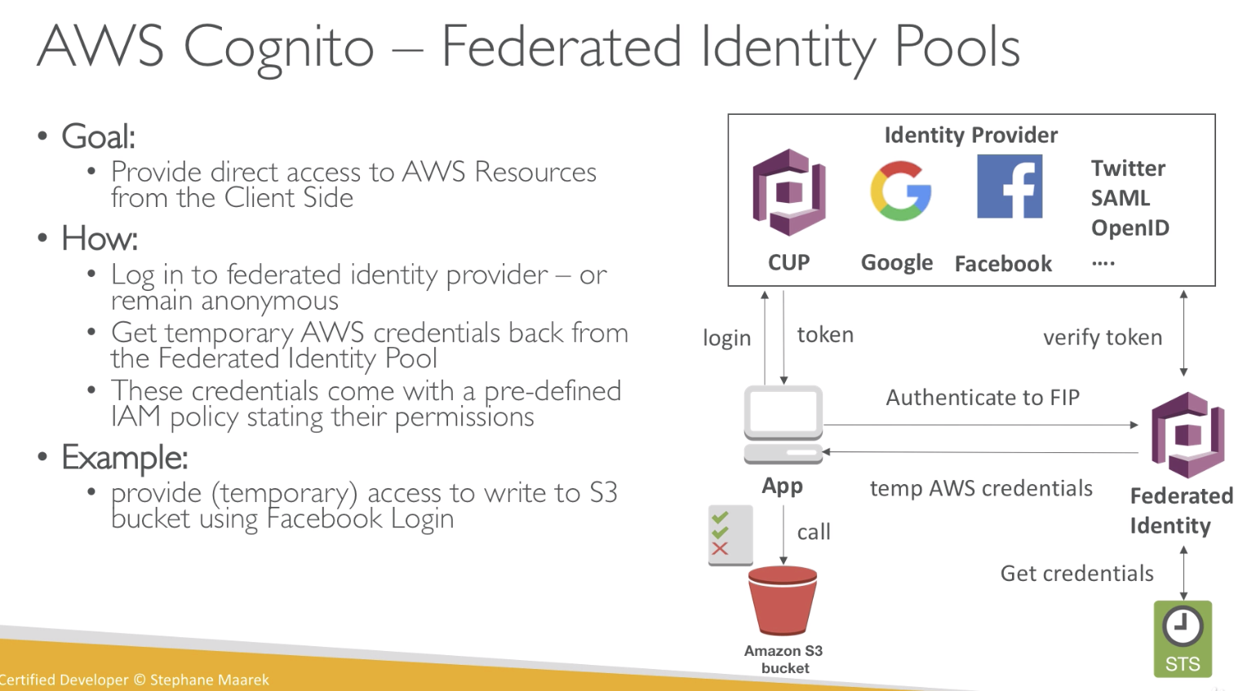

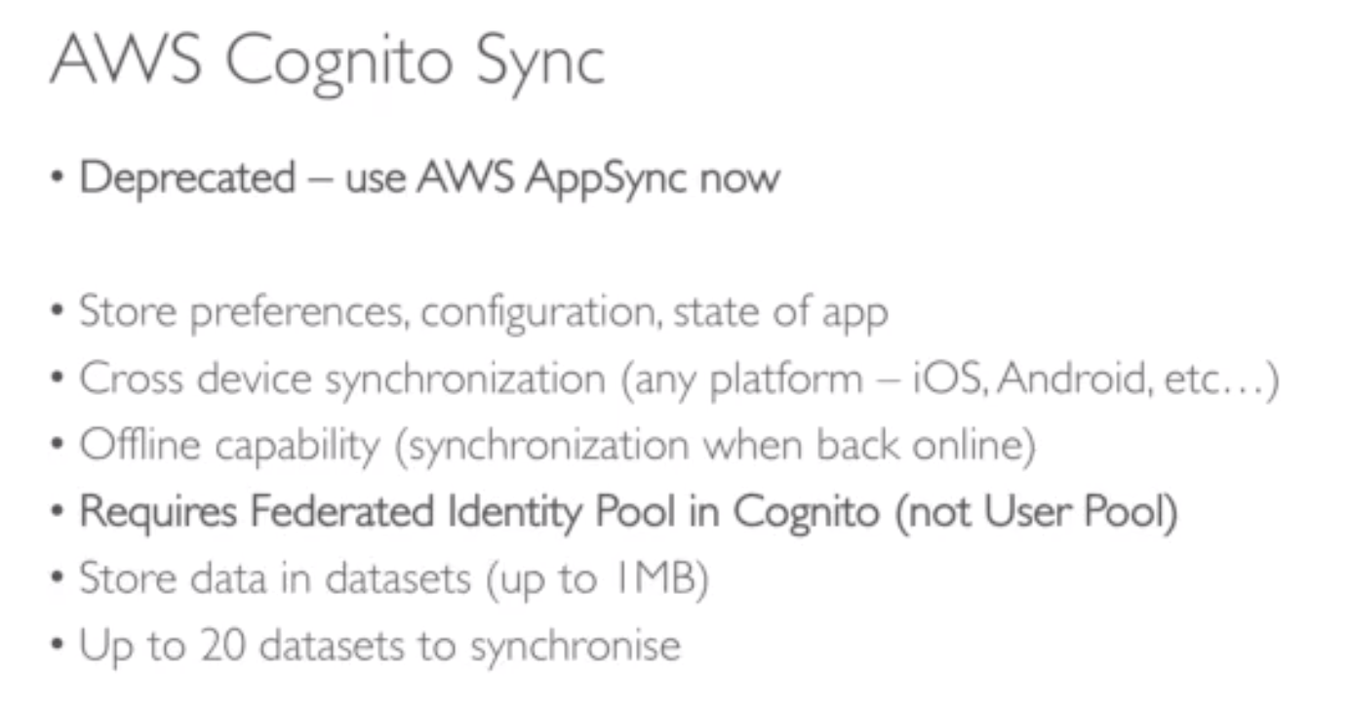

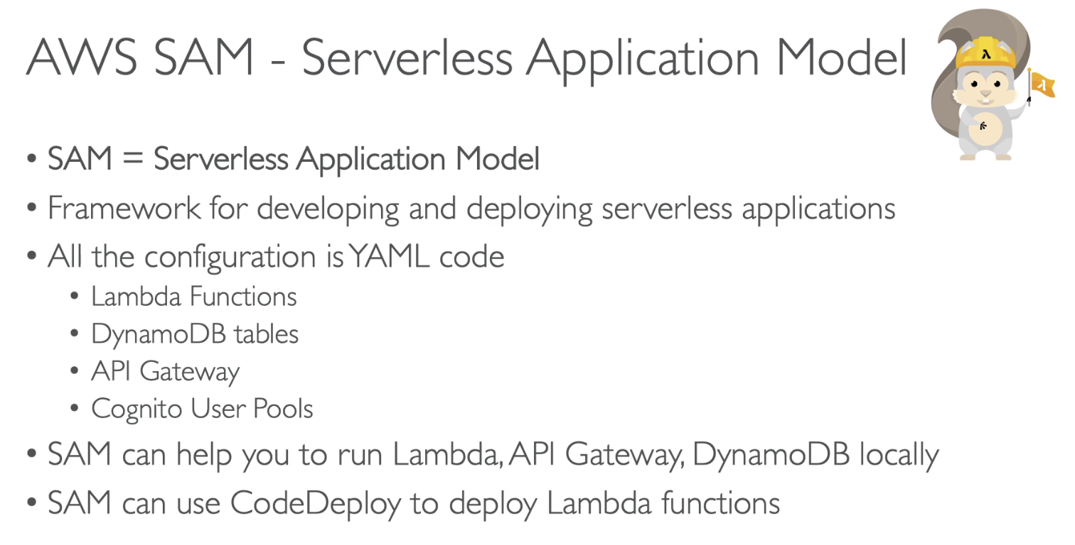

# Section 16: Serverless Solution Architecture Discussions

## 185. Mobile Application: MyTodoList

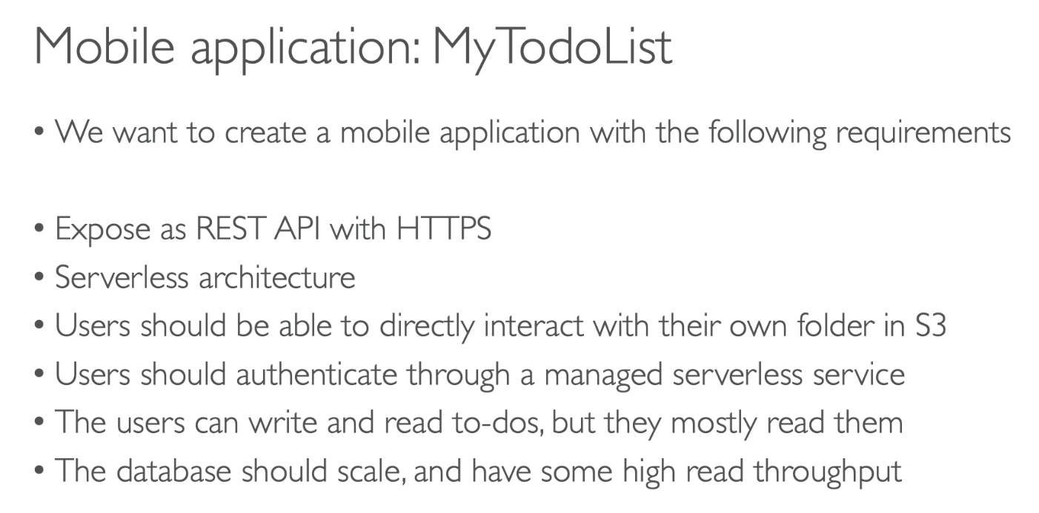

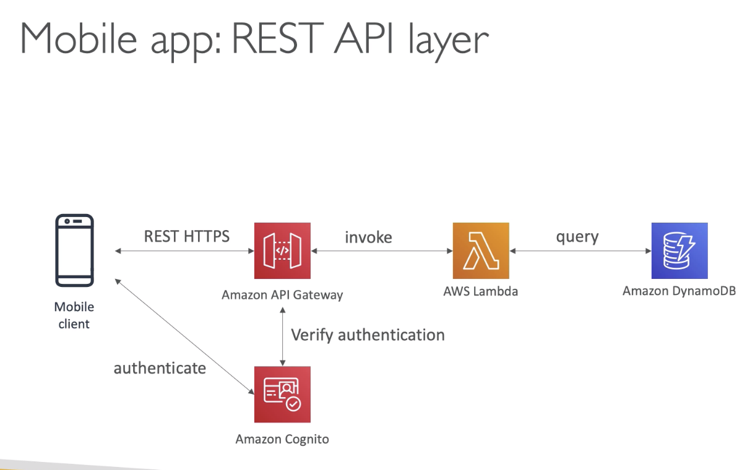

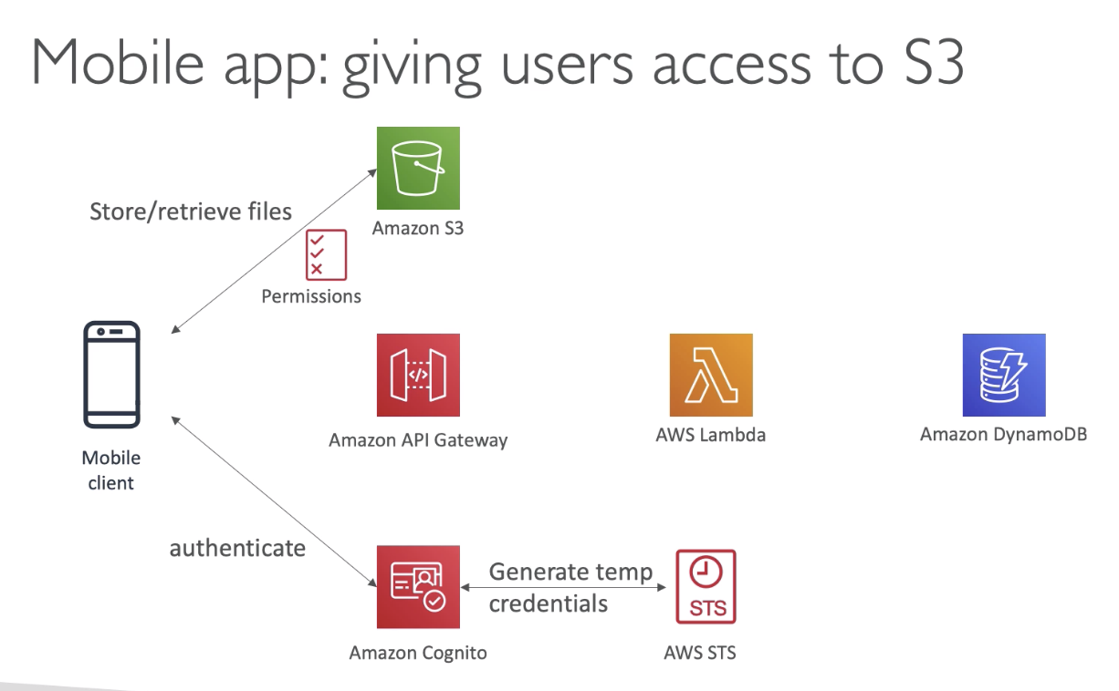

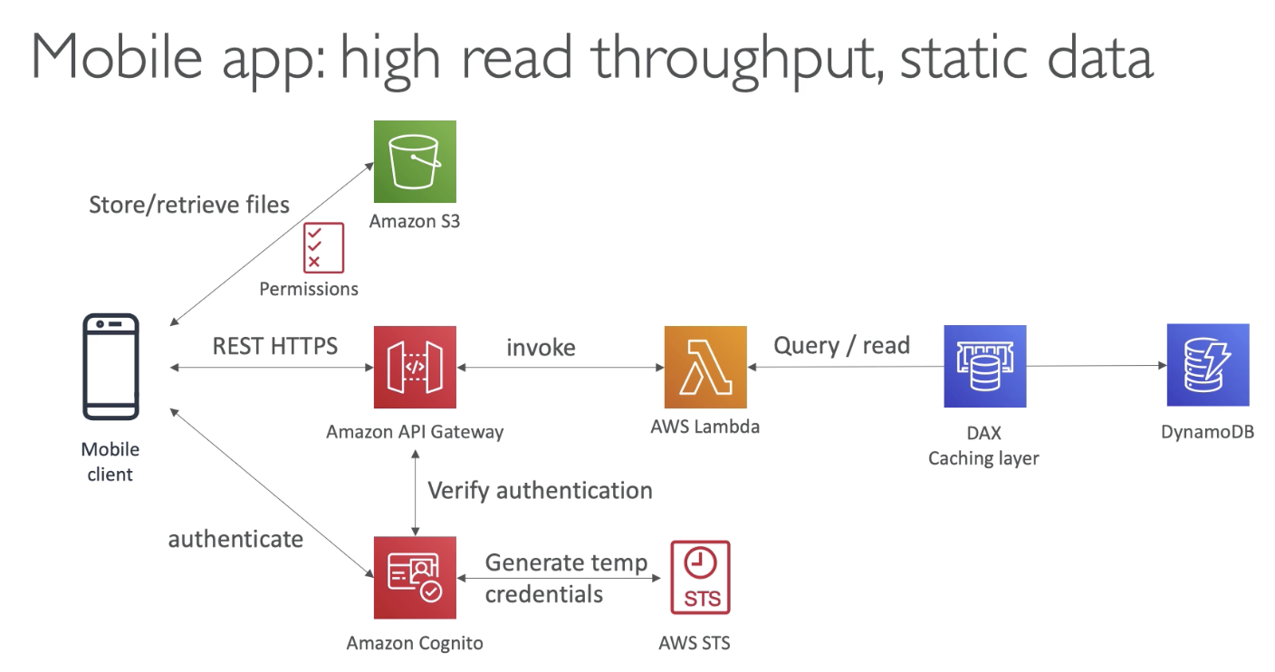

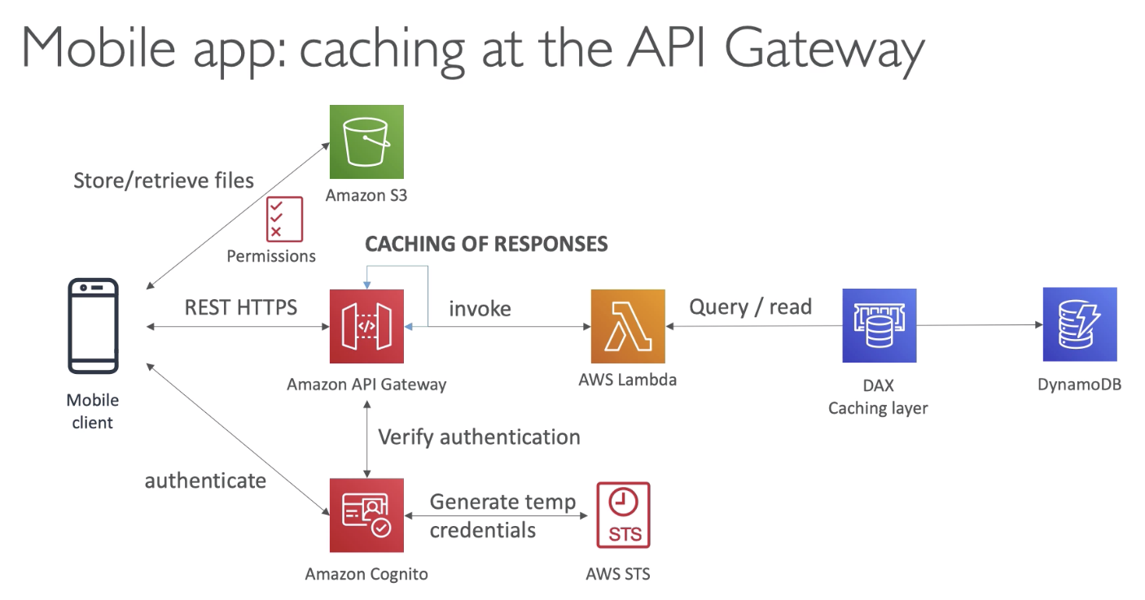

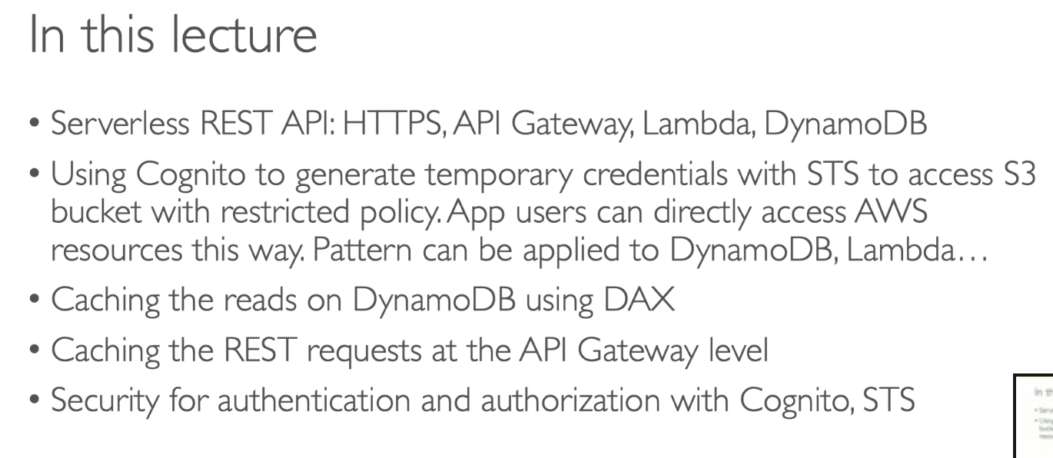

## 186. Serverless Website: MyBlog.com

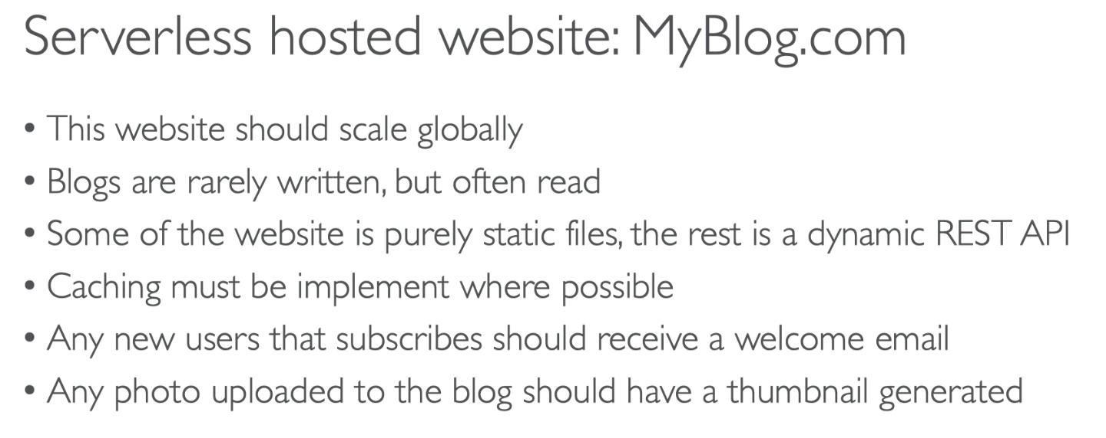

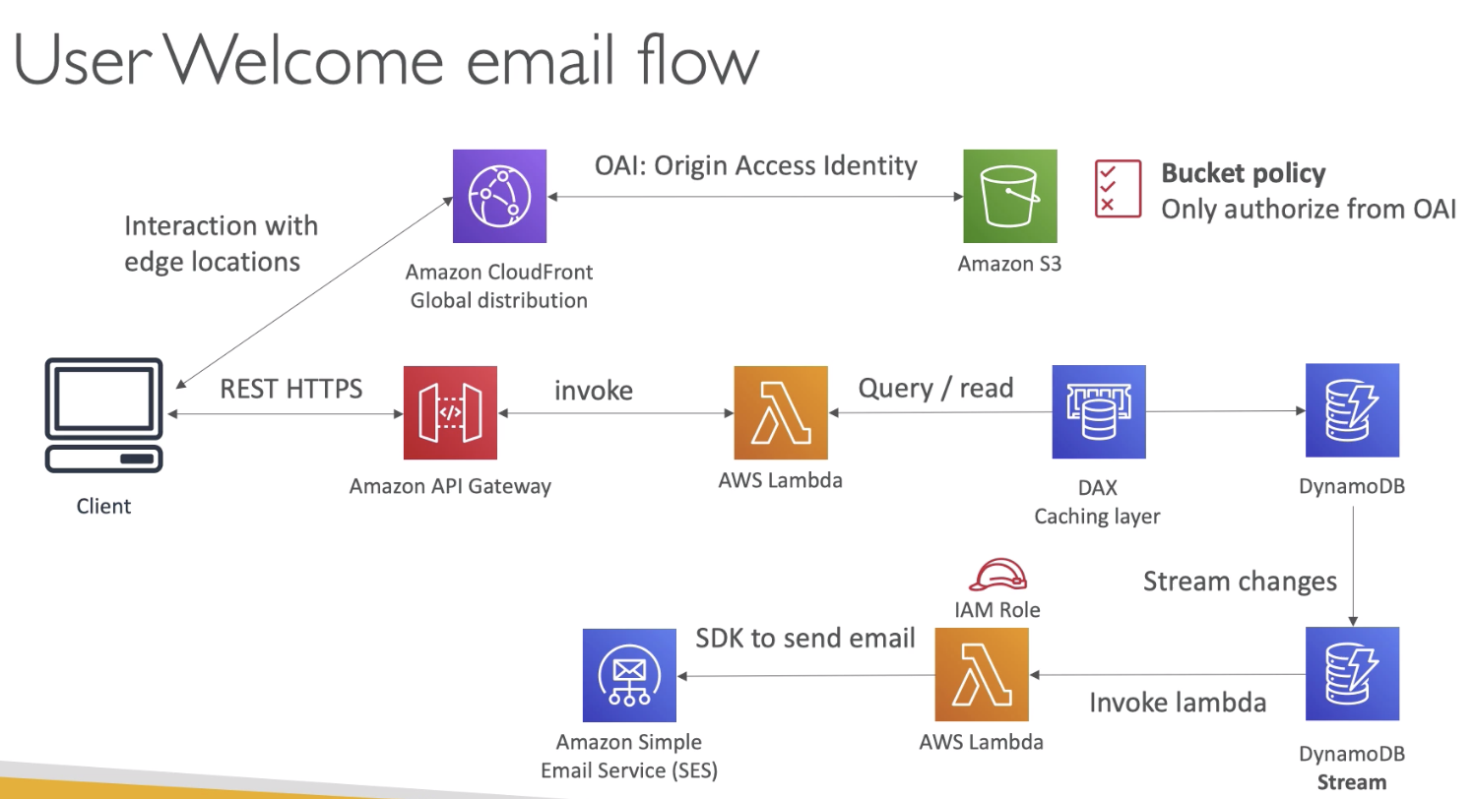

* Static content will be saved in S3 bucket
* How do we expose that bucket? S3 is local to a region.
  + Use Amazon Cloud front, it is a global distribution. User will use the Edge location of CDN. And cache the response from S3.
* Security:
  + Use OAI from Cloud Front to S3. Basically add a bucket policy and the bucket policy will say you only authorise OAI / Cloud front to read.
  + So now our client cannot directly go to the S3 bucket to get the content. They will have to go through OAI. This was we can secure our infrastructure.
* To save data:
  + Use DynamoDB database
  + DAX is the caching lyre, as the reads are more
  + API Gateway will expose the rest endpoints
* Email flow:
  + DynamoDB Stream will invoke lambda function, which will use SES to send emails
* Thumbnails for images in the S3 bucket:
  + Client can upload images to S3 directly. Or it can use CloudFront distribution (use Transfer Acceleration), which will forward them to S3 bucket.

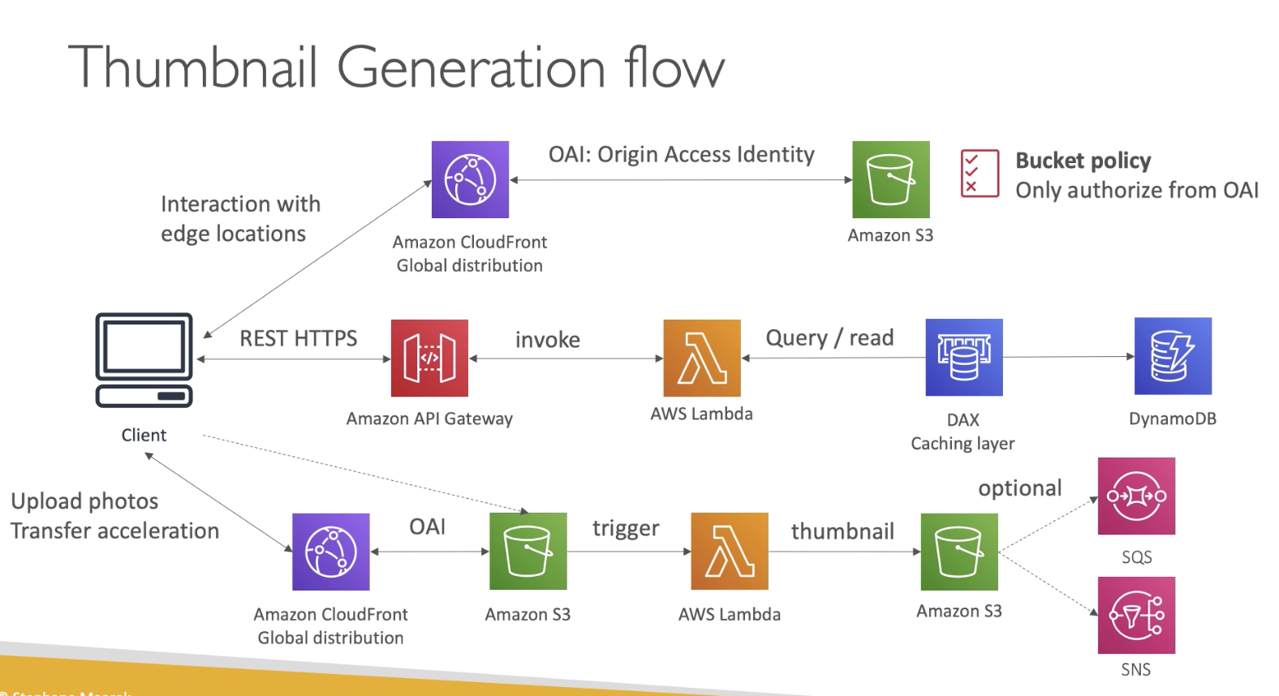

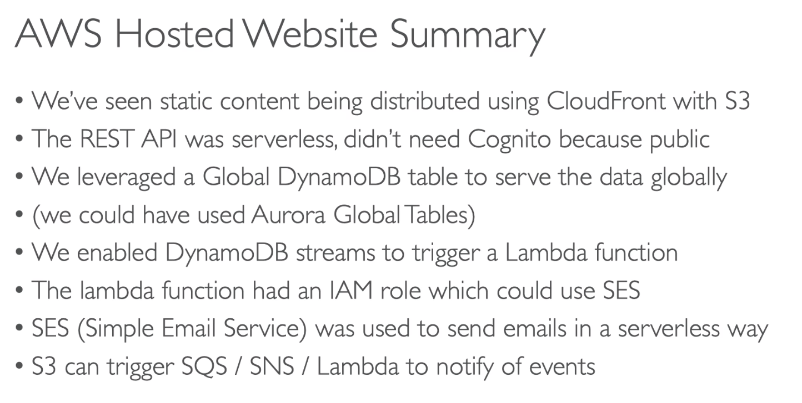

## 187. Microservice Architecture

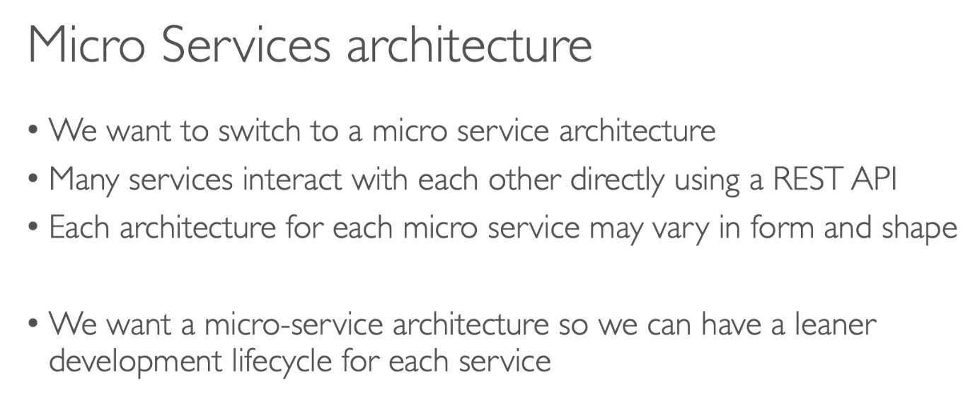

We also want each service to:

* Have leaner development lifecycle
* scale automatically
* have its own code repository.

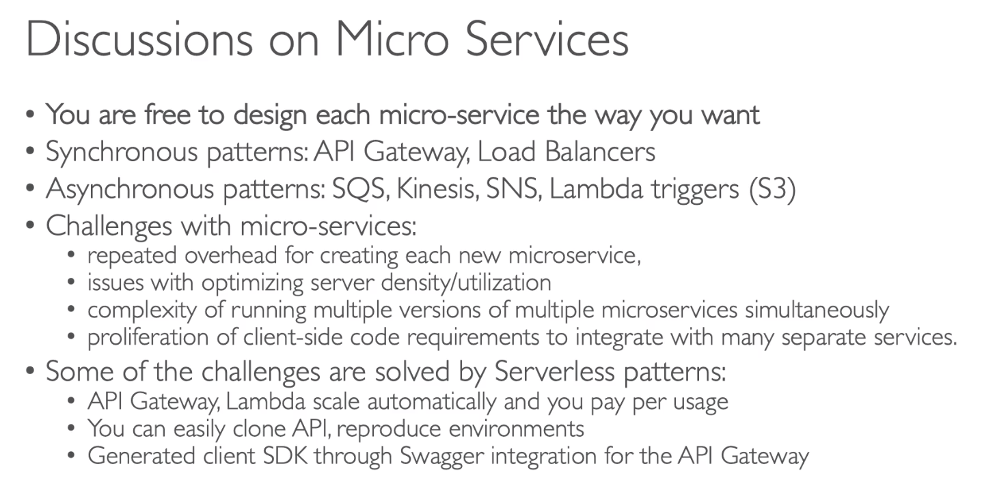

## 188. Distributing Paid Content

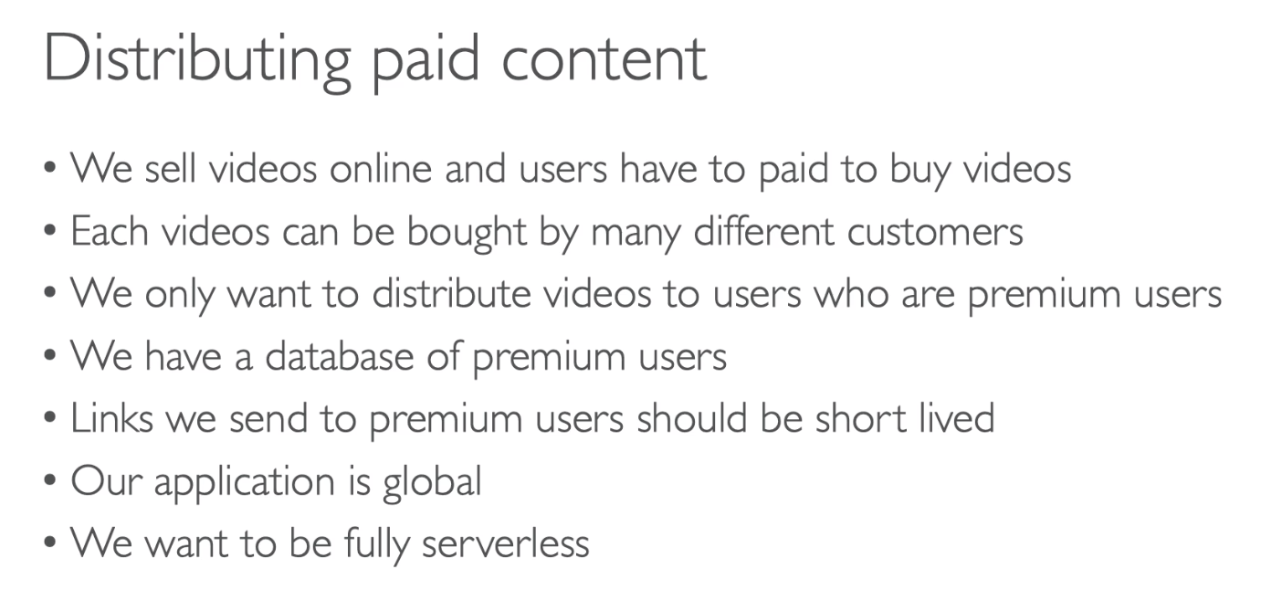

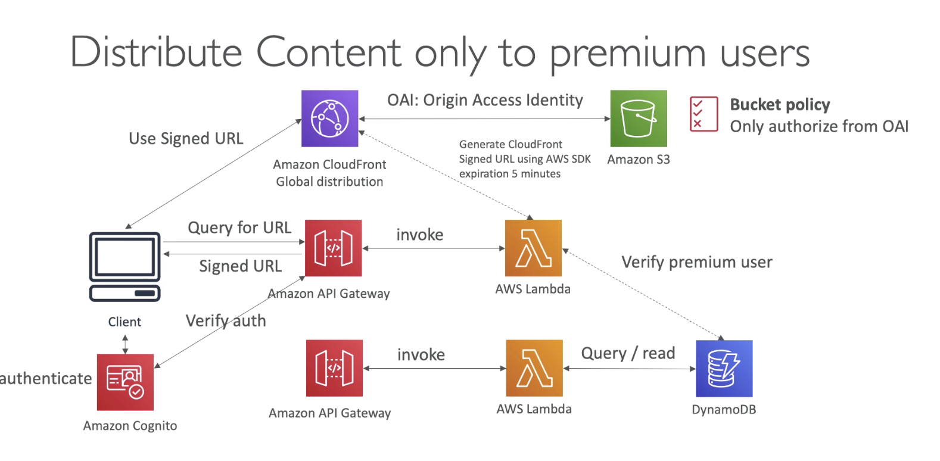

* DynamoDB maintains the table of premium users
* Cognito will verify user authentication with API Gateway
* S3 bucket will store all the videos but we need a global distribution, so we would CloudFront global distribution using OAI.
* We want to distribute videos to only premium users, so we will generate signed URL.
  + Create another API Gateway, which will invoke a Lambda function
  + Lambda will verify with dataset if the user is premium, then use CloudFront to generate a signed URL, which is valid for short time, say 5 mins.
  + And return the url back to users
  + This is how we ensure the video download link is not accessible to everyone

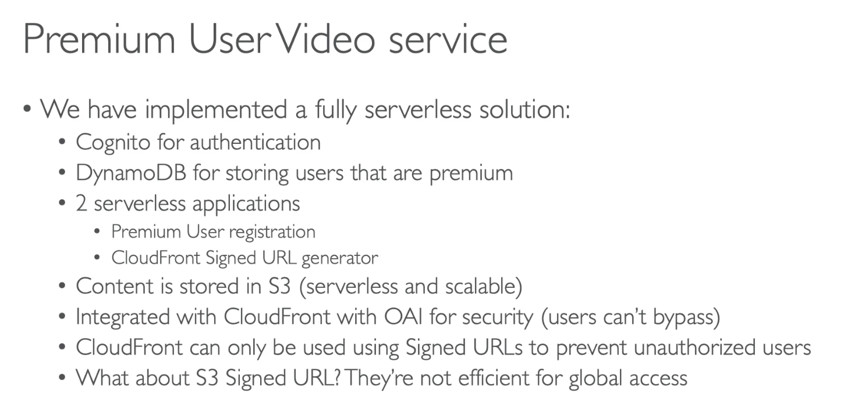

## 189. Software updates distribution

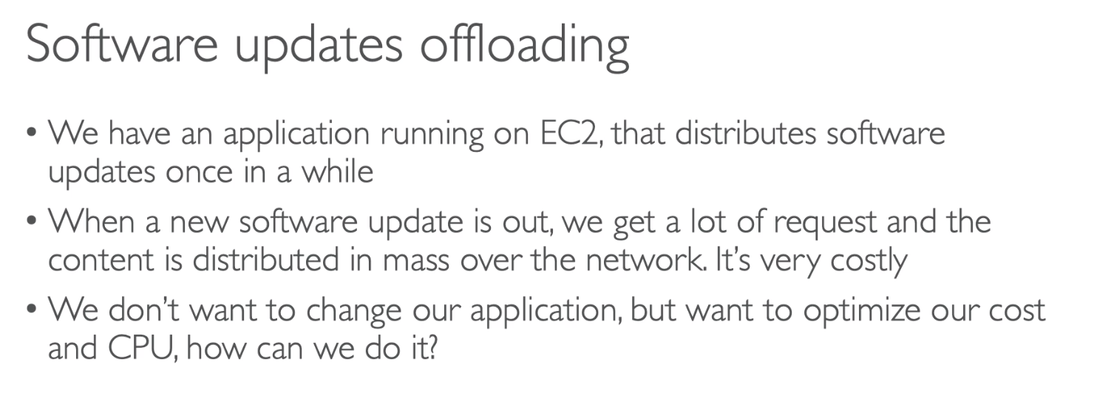

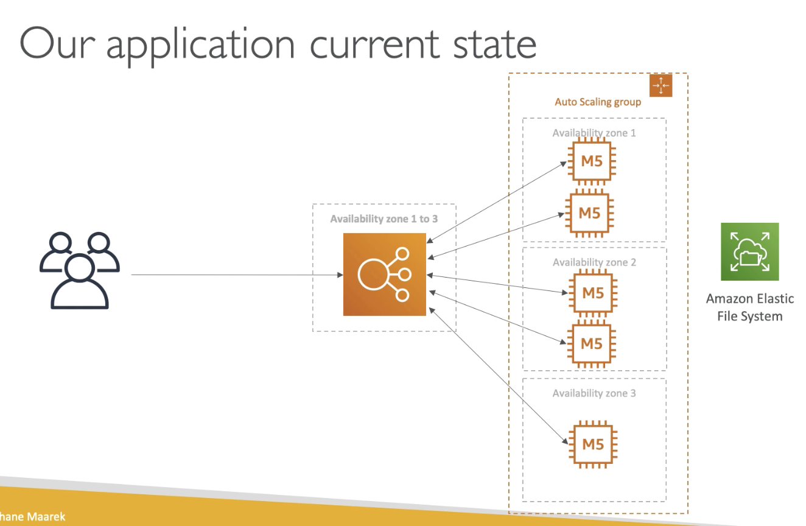

How can we make this application to

* Scale more globally
* Reduce CPU utilization and cost

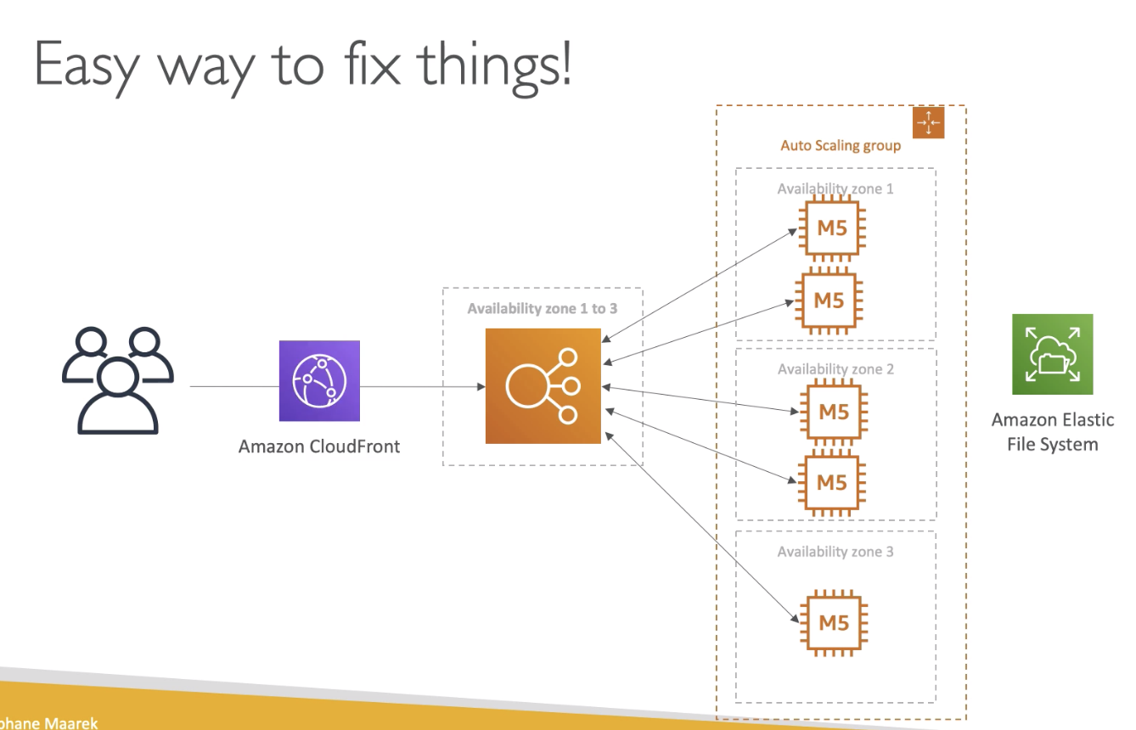

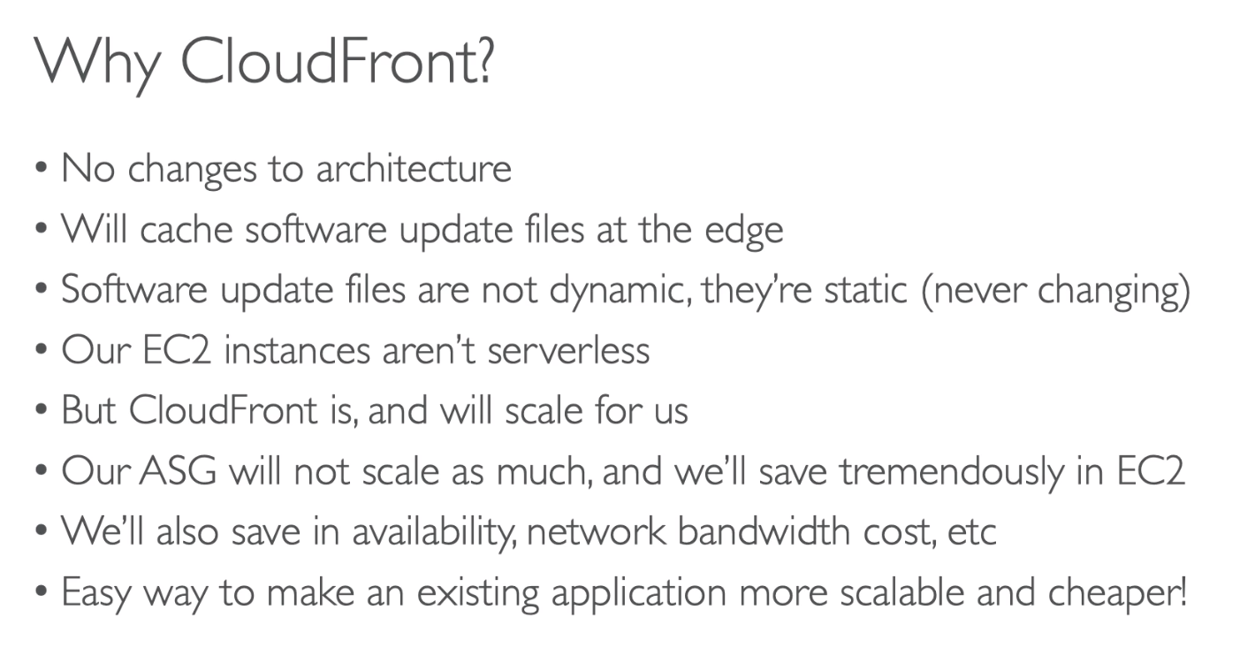

CloudFront is an easy way to make your existing application more scalable and cheaper, if it is mostly static content. Just by using caching at the edges all around the world.

## 190. Big Data Ingestion Pipeline

